Chapter 25 (and end of 24): Lecture Notes

These notes cover some of the material that will appear on the last exam:
Friday Dec. 7.
The rest is in chapters 26 and 27. It is a lot of material—get started now!

First must discuss the “Hubble law” so that you are comfortable with the idea that → redshift is the same as distance is the same as how long ago.
You also have to be comfortable with the “distance ladder” that we have been building throughout the semester. So we begin with basic ideas of making a map of the local, and then not-so-local, universe.
(Continuation from Chap.24: Review of sec. 24.2):

How are the different kinds of galaxies distributed in space?
That is the main topic of the next two lectures, the key to discovering the larger-scale structure of the universe, and even its history and clues to its origin.

We are trying to make a map of the entire universe, by locating all its contents. To do this we need big telescopes (to see faint objects, since they are far away), and some method to get distances to very distant objects. So we are still “climbing the distance ladder” (the pyramid your book has been constructing).

Groups of galaxies— We can use Cepheid variables (from their period-luminosity relation) to make a map of our “local” galactic neighborhood (can get distances out to about 15 Mpc with this method). We find that nearby galaxies are clustered.

Our Local Group—About 50 galaxies within about 1 Mpc of each other. (Look at Fig. 24.13)

(1 Mpc = 1000 kpc = (roughly) 10 x size of our Galaxy. This will be our unit of distance from now on: the megaparsec.)

Most of the mass of the Local Group is in the large spirals Milky Way and Andromeda (M31).
Most of the number of galaxies are small dE and dIrr galaxies.
Many of these are satellites of larger galaxies (e.g. 3 or more satellites of Milky Way are LMC, SMC, and Sgr dwarfs, a few others that are more distant; Andromeda has several small satellites.

To get to larger distances, must use brighter standard candles. The next technique in the ladder of standard candles is the Tully-Fisher relation ⇒ very tight relation (for disk galaxies) between rotational velocity (from broadening of galaxy’s spectral lines—see Fig. 24.11) and luminosity. (Think why this makes sense: the galaxy’s rotation is balancing its gravity, which is due to its mass, related to its luminosity…)

So for a galaxy too far away to use any other method, just obtain a spectrum (21 cm neutral hydrogen line is best) and measure width of line; the Tully-Fisher relation then gives you the luminosity, so (knowing the apparent brightness) you get the distance.

This method can be used out to about 200 Mpc ⇒ allows us to make a map of the relatively nearby universe, but far beyond our Local Group.

Before looking at the results, there is one more rung in the ladder of distance indicators or standard candles, called the Hubble relation or Hubble’s law, to consider. But it is much much than simply a technique for obtaining distances: It is our first big clue about the origin of the universe.

Hubble’s Law (Sec. 24.3)

“Hubble’s law” is the basis for our ideas about how the universe formed (the “big bang” theory), so important to understand it.

Using galaxies of known distance (e.g. using Cepheids, Tully-Fisher effect), find that most galaxies, especially the more distant ones, are moving away from us (or we from them): Also,

→ The velocity of recession (redshift) increases linearly with distance
(24.16, 24.17). Indicates that universe is expanding.
Mathematical version of this statement:
Recession velocity = constant (H₀) x distance ⇒ Hubble’s law
The constant of proportionality is called the Hubble constant, which is a fundamental measure of age of the universe (next section of course—for now we just want to use it to get distances and map the universe).

Think about how the value of the Hubble constant is determined, and then how it can be used to obtain distances to any object whose spectrum you can detect.
See Fig. 24.18 on the “cosmic distance ladder.” You should understand what these different distance indicators are, and why each can only be used out to a certain distance.
(Notice that supernovae, as standard candles, actually belong at the top of the pyrimid—we will see why this is important a little later.)

[Textbook discusses active galactic nuclei, including our own, at this point, sec. 24.4 and 24.5; we are not going to cover that material, either in class or on the exam.]______________________
Now go to sec. 25.5, The Universe on Large Scales, to continue along the same theme. We will not follow the material in the same order as in the book, but will come back to the early material in chapter 25 after we complete our “tour” of the structure of the universe.

Galaxies and Dark Matter (Ch. 25, starting with 25.5, The Universe on Large Scales)

Mapping distances to more and more distant galaxies, we find that galaxies occur not only in small groups like ours, but in larger galaxy clusters.
The nearest substantial cluster is the Virgo Cluster, whose center is about 20 Mpc away. It contains about 2500 galaxies, with a size of about 3 Mpc. We are located in its outskirts. i.e. our Local Group is in a sense a satellite of the Virgo Cluster.

Redshift surveys as maps of the universe

Using the Hubble relation, we can get distances to galaxies even farther away if we can obtain their spectra, so we can get their redshift and calculate the distance from the equation given earlier.
But we do need a lot of spectra to get all these redshifts: We needed redshift surveys.
[Think: redshift survey = survey giving distances to a large number of galaxies using redshifts and Hubble’s law. See Fig. 25.23]

The earliest redshift surveys showed that the Virgo Cluster is only one of many clusters that make up our local, or Virgo, “supercluster” (see Fig.25.21, 25.22), which is about 100 Mpc in size, containing about 10,000 galaxies. Notice the Virgo Cluster and our Local Group near the center of these pictures.
We are interested in the blobby patterns in Fig. 25.22, the frothy structure in Fig. 25.24, as showing us the structure of the universe:
The galaxies were just “tracers” of this structure, which is
our true target.
Also: in the spectra of distant galaxies, we can see that intergalactic space is littered with the gas clouds, the “Lyman alpha forest” (25.25). These are probably too small to form galaxies, but reveal yet another formerly invisible component of the universe.
Structure of the universe using redshift surveys, continued.

The collection of redshifts for tens of 1000s of galaxies took many years on the largest telescopes, but gave us a useful map of the universe out to about 1000 Mpc (e.g. the Las Campanas redshift survey shown in Fig. 25.24).
The Sloan Digital Sky Survey and other enormous projects have now provided redshifts for millions of galaxies! READ Discovery 25-1, which is only a little out of date—search internet for details of some of the discoveries and updates from Sloan, and additional redshift surveys.
Some results from the large redshift surveys (this takes us from about the 1980s to the near-present) are shown together in the image on the next page of these notes, and discussed in the text.
Extending out to 200 Mpc (Fig. 25.23) and 1000 Mpc (Fig. 25.24) we see larger and larger structures, often huge filaments (e.g. the “Great Wall”, 25.23) and enormous voids. The galaxies in the universe are apparently hierarchically clustered up to structures with sizes of around 200 Mpc, but nothing larger (we’ll see why this is important in the last chapter). How far does the universe extend? Could it be 10,000 Mpc?
100,000 Mpc? Infinity? Hint: the age of the universe is about 10 billion years.
(Remember the distance between our galaxy and our nearest neighbors is less than about 1 Mpc—now we are talking about
1000 Mpc = a billion parsecs. Then remember that the distance to the nearest stars are a few parsecs, and the size of the solar system is about 1 ten thousandth of a parsec.)
Conclusion: The universe as a whole, or at least the part that we can see, appears to be a frothy structure of filaments and bubbles surrounding low-density voids. We trace this structure with galaxy positions, but today we understand that most of this structure is actually the mysterious dark matter, whose gravity has apparently dragged the visible matter along with it into this structure.
That is the subject, dark matter, to which we now turn, as we return to sec. 25.1. We will return to the last few pages of this chapter, mapping dark matter structure with “gravitational lenses” at the end of the dark matter discussion.
See “map” on next page for a review of the largest redshift surveys.

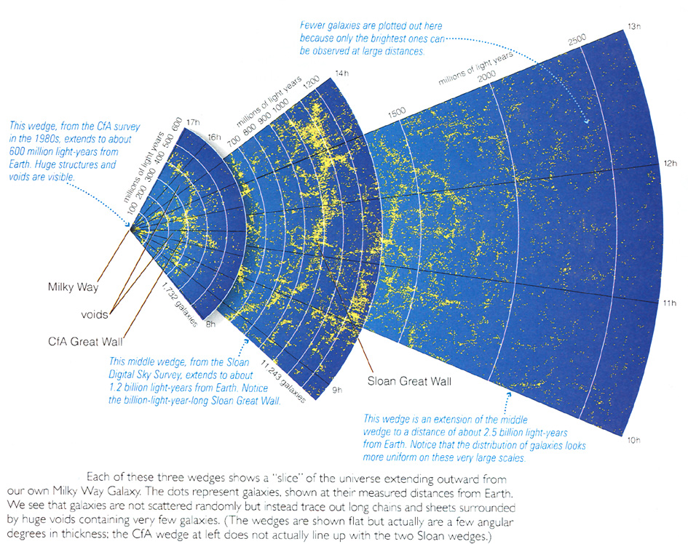

Now we return to the beginning of chapter 25.

Evidence that most of the matter is “dark matter.”

So far we have concentrated on the distribution of galaxies in the universe, but let’s return to individual galaxies and clusters of galaxies to see what their masses are—we will find that we are only seeing the “tip of the iceberg.”

Masses of galaxies—rotation curves (Fig. 25.1; reread ch. 23.6, p. 636 if you’ve forgotten this for our Galaxy) are flat NOT “Keplerian” (see figure below) as expected.
This indicates ~ 30 to 90% of mass is invisible “dark matter” (i.e. masses come out about 5 to10 times larger than what we can see in any form, at any wavelength). This is similar to what we found from the rotation curve for our Galaxy. We are going to see it again and again, even for clusters and superclusters of galaxies, showing that “dark matter” is probably everywhere, and is most of the universe. We are a little like the detritus of structure formation in the universe. But first, back to rotation curves:
Illustration below is to review what a rotation curve tells us about the mass distribution in any system.
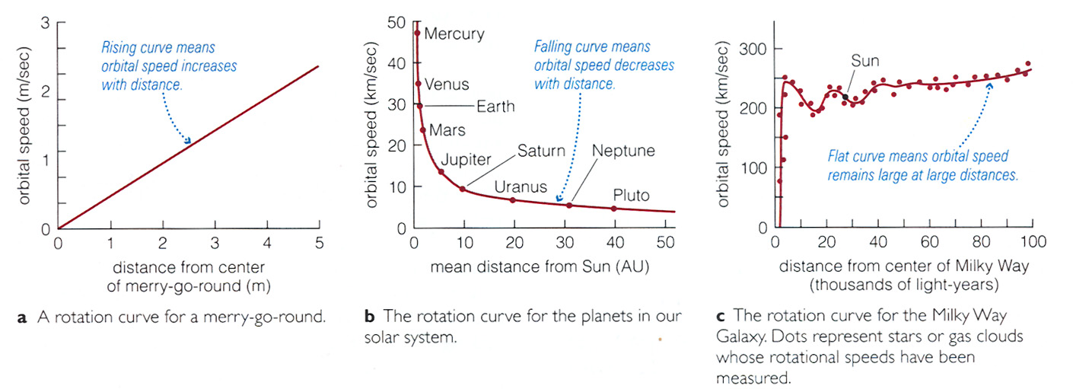
You should be comfortable with the idea of “Keplerian rotation” (as if all the mass were concentrated at the center of the system, like in our solar system (hence “Keplerian”, Kepler’s laws).
Rotation curves and dark matter: More detail.
How do we get rotation curves for most (disk) galaxies?
Doppler effect using the neutral hydrogen 21 cm line: Think about how we have used the Doppler effect to learn how fast stars rotate, from the width of the line (because we couldn’t resolve stars). But for
galaxies, we can measure the radial velocity as a function of distance from the center of a galaxy.

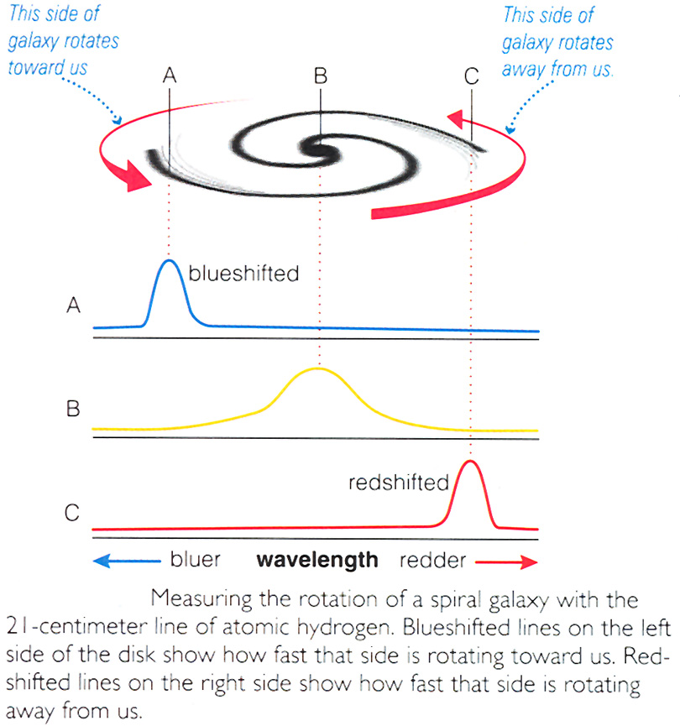

Result: Most disk galaxies have rotation curves like the Milky Way
→ dark matter dominates all galaxies that have been studied.

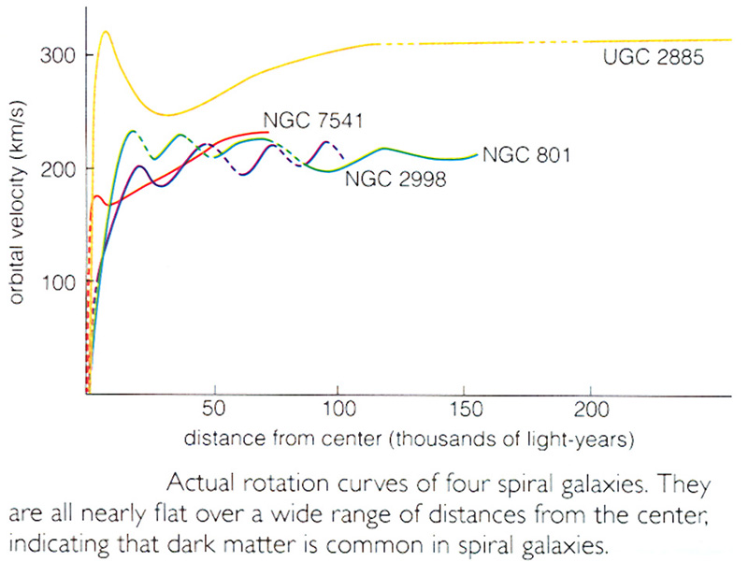

More evidence for dark matter:

Masses of binary galaxies and clusters of galaxies—from motions of galaxies in clusters (Fig. 25.2).

Inferred masses of clusters of galaxies—from how much mass you would need to account for the speed with which they are moving--again come out about 10 times larger than what we can see in galaxies. Could it be outside of the galaxies? We already mentioned the Lyman alpha forest, but that turns out negligible in mass.

Some of the mass of clusters turns out to be observable in the x-ray part of the spectrum: clusters of galaxies are filled with extremely hot (tens of millions of degrees) gas. However the total mass of this “inctracluster gas” (images shown in 25.4) is only comparable to the mass of visible galaxies, so hot cluster gas doesn’t account for the “missing” mass.

Again we find that most of the mass in clusters is unseen “dark matter.” (Get about the same thing from estimates of masses of binary galaxies—see 25.2; 25.3 for speculation that there could be “dark galaxies.)

Finally, can even estimate the amount of unseen matter needed to produce the distorted images of galaxy clusters (25.29) by gravitational lensing (25.27, 25.28). Again, need large amounts of unseen matter everywhere. Some regard this as the only direct detection
of dark matter (see the “dark matter maps” in 25.30 and 25.31)
⇒ must face fact that most of the mass of the universe is in a form we can’t see, i.e. that doesn’t emit light at any wavelength. What is it?
See earlier discussion in textbook (sec. 23.6). Probably unknown exotic fundamental particles, but still uncertain. Whatever it is, it probably dominated the evolution of the universe. We will see evidence for this later.

Formation and evolution of galaxies (Sec. 25.2 and 25.3 are very good on this subject—you should read it on your own, since the subject is vast and we will only discuss briefly in class. Also, sec. 25.4, on giant black holes at the centers of galaxies, is one of the hottest topics in extragalactic astronomy today, but adds too much material for you to study and remember, so please read it, but it won’t be on the exam.)

Theoretical simulations and observations of galaxies very far away (and so when the universe was much younger) are giving a consistent (and surprising!) picture: That the first galaxies were small irregular objects that repeatedly merged in collisions to produce larger and larger galaxies.
Much of this comes from the observations known as the “Hubble Deep Field”—see Fig. 25.10 in text.
When two similarly sized disk galaxies merge, the product (in simulations) looks very much like an elliptical galaxy. (Not sure what fraction of ellipticals formed this way.) You can see the effects of galaxy collisions in the form of tidal tails (25.8, “The Antennae”) and ring galaxies (25.6, the “Cartwheel” galaxy). These images of real galaxies match theoretical simulations of galaxy collisions very well (see right side of Fig. 25.8).
Here are two examples of interacting galaxies. The lower one might resemble our own galaxy’s interaction with the Large Magellanic Cloud.

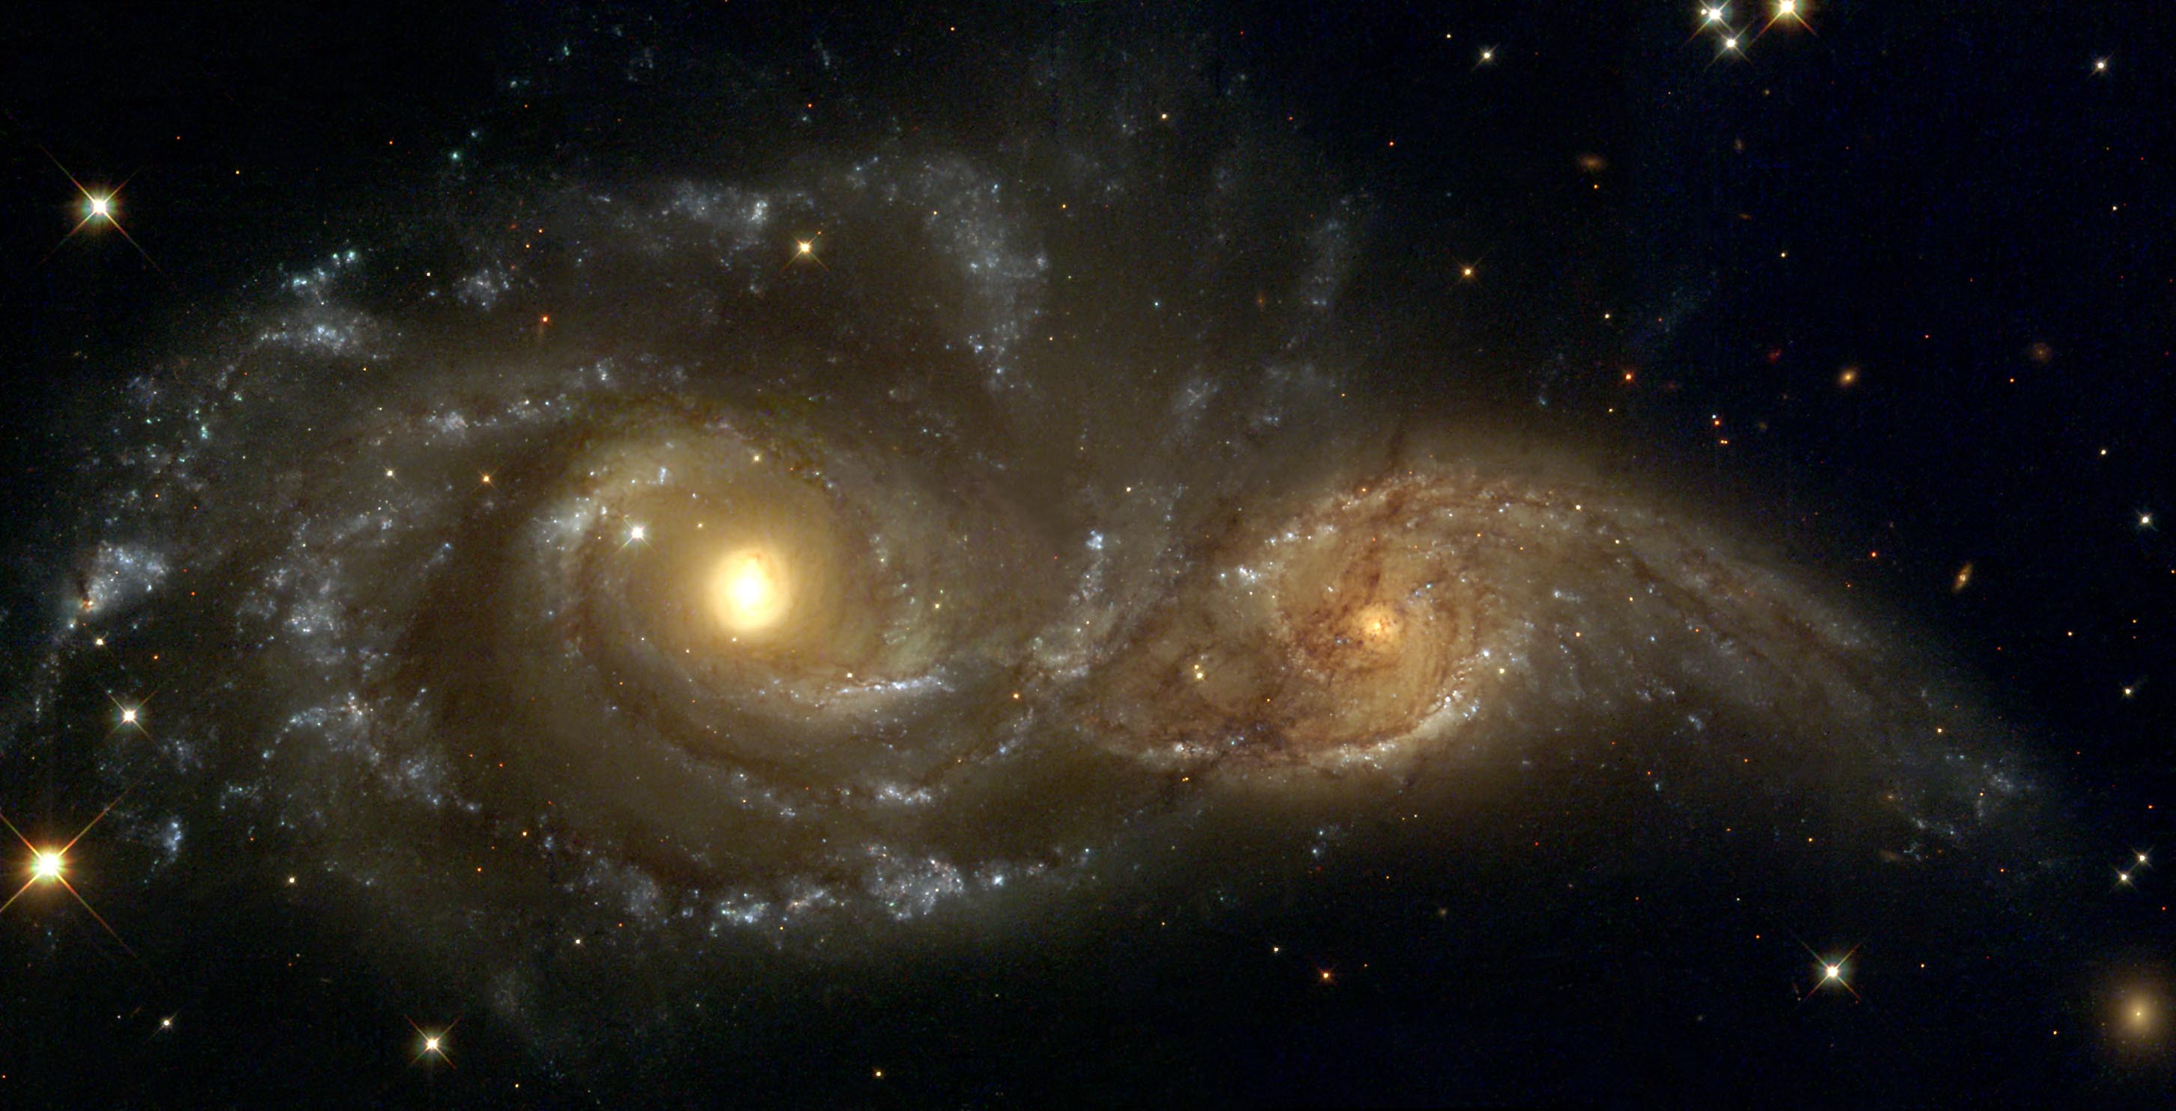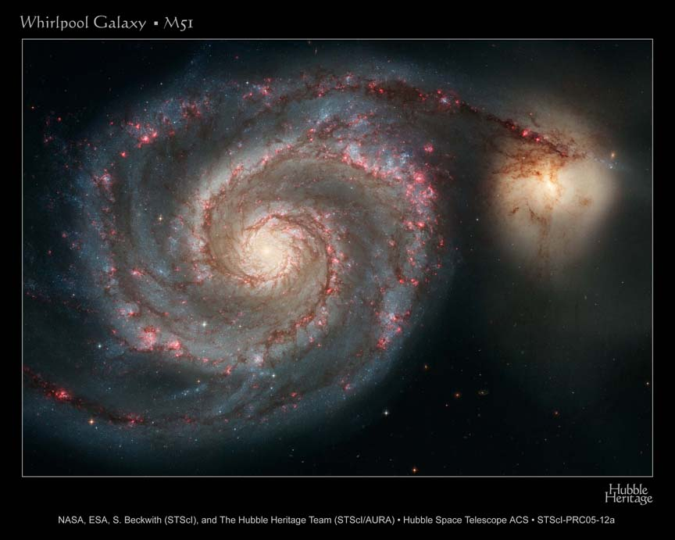
Galaxy collisions, concluded.
Most large galaxies have probably been pummeled many times by smaller galaxies without affecting their overall type. E.g. the Milky Way has probably “ingested” several small dIrr galaxies.

Many other collisional effects can occur, e.g. excitation of spiral arms (25.14); tidal tails (25.8); starbursts (25.11); galactic cannibalism by giant ellipticals in the centers of rich clusters (25.12), and more. Fifteen years ago astronomers were skeptical whether collisions affected any but a tiny fraction of galaxies, but today it is understood that collisions and mergers probably dominated the early evolution of galaxies in our universe.

Another relatively new feature concerning galaxy evolution is the likely existence of supermassive black holes in the nuclei of galaxies—is this how galaxies began, or did these BHs develop some time in the evolution of galaxies? Read sec. 25.4 for your own interest, but the material will not be on the exam. (One of the discoverers of the black hole mass-galaxy mass relation is a UT professor, Karl Gebhardt, the same Gebhardt who was mentioned as finding massive black holes in the centers of globular clusters.)

That concludes our discussion of the really minor activity of the leftover visible leftover matter blobs, galaxies, that trace out the structure of the dark matter, that traces out the structure of the universe. The galaxies themselves have interesting lives, as we have seen, but they
are trivial activities compared to the overall structure and evolution of the universe, difficult as that is to face. So now we come to the “big questions,” those having to do with “cosmology.” First on the list:

We have seen that the universe of galaxies (and the dark matter that the galaxies trace) is structured from “tiny” loose groupings like our Local Cluster (~1 Mpc in size) to huge superclusters and filaments up to ~ 200 Mpc in size.
How did this structure come to be? Simulations show that if you start with some “seed” galaxies in an expanding universe with dark matter, the galaxies’ gravitational attraction on each other does lead to this kind of hierarchical clustering. (Some stills from a simulation are given on the next page of these notes.) But the ultimate origin of this structure is in the “seeds,” which we will later try to trace back to sound waves before galaxies ever formed, and back further still to “quantum fluctuations” that were the ultimate source of structure in our universe.

