Before proceeding to Chapter 20…
More on Cluster H-R diagrams:
The key to the chronology of our Galaxy
Below are two important HR diagrams:

1. The evolution of a number of stars all formed at the same time in a cluster. Note that both during the approach to the main sequence and evolution away from the main sequence the most massive stars evolve most rapidly. This is what gives us a way to obtain ages of clusters from the extent of the main sequence.
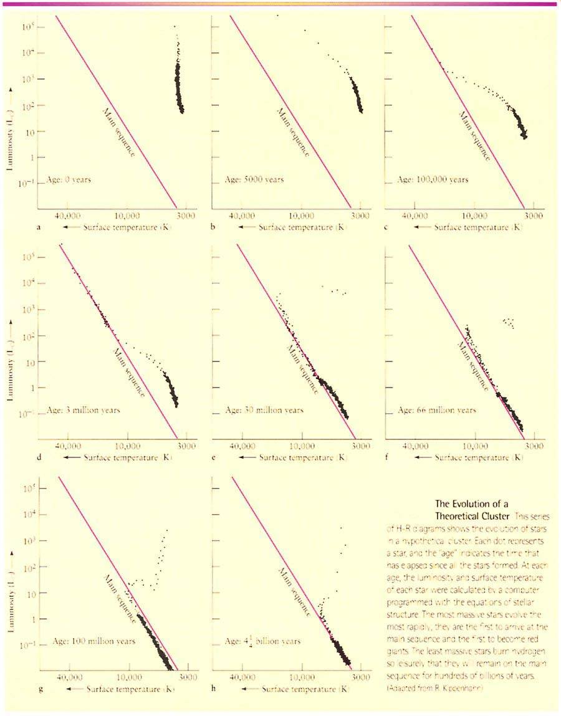
2. This illustration shows some HR diagrams of real open clusters, illustrating directly how ages of clusters can be estimated. The oldest cluster known, M67, is only about 4-5 billion years because almost all clusters dissolve or “evaporate” long before this. M67 is just a “lucky survivor.”
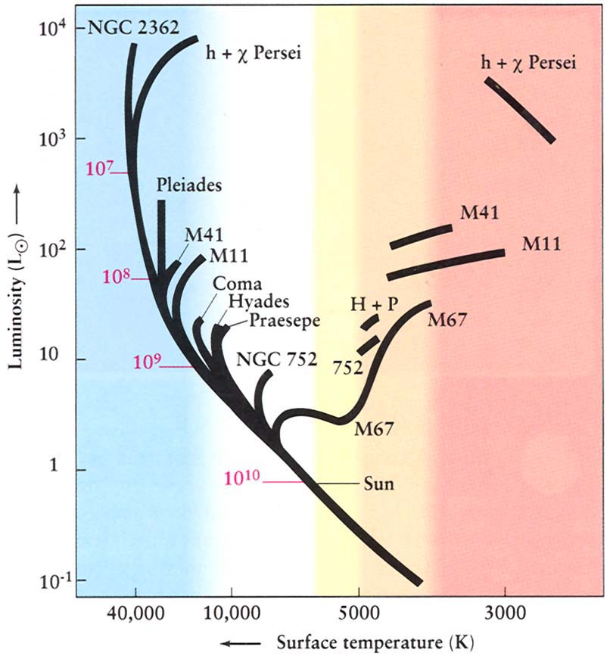
At this point you should be able to look at Figures 19.17 (open cluster) and 19.18 (globular cluster) on p. 519 of your book, and understand clearly how we know that one was “just born” recently (about 100 million years ago), while the other must be extremely old, about 10 billion years.
Can you now guess why so many globular clusters have about the same (old) age, and are still “in one piece” (not dissolved), while not a single open cluster is older than about 5 billion years, and nearly all of them are younger than about 100 million years? Does this suggest that there were few open clusters forming until recently, with our Galaxy in a “lull” or “off” state for nearly 10 billion years? Why would all the globular clusters form 10 billion years ago?

Stellar Evolution (ch.20)
So far all we know about stars’ lives is that they are formed within interstellar clouds by contraction under self-gravity, contract until they are hot enough in their cores to burn nuclear fuel, and that the lowest-mass stars live longest. Next we summarize the stages of a star’s life after it begins it’s main sequence stage of evolution, going into some detail. Note that the statements made about stellar evolution are almost entirely theoretical, but form one of the best-established and tested parts of astronomy—stars are not so complex that we can’t make models for them (compare with biological organisms). And there are some observational tests: The cluster H-R diagram above is one of them.

Main Evolutionary Phases for Stars ~1Mo to ~8Mo

(Notation from here on: Mo means M_{sun} = mass in

units of the Sun’s mass)

Main sequence equilibrium
1. Pressure balances gravity at every depth, so hottest in center ⇒ nuclear reactions H → He, “core H-burning”, which is what the main sequence in the H-R diagram represents. This is the same “pressure equilibrium” that we have discussed earlier, but a star has a long-lived source of energy to maintain that pressure.

2. Two nuclear reaction processes can occur in main sequence stars: proton-proton (dominates in stars ~ sun’s mass and lower), and CNO cycle (dominates in stars more massive than sun; see More Precisely 20-1).

3. Stable, lasts most of star’s lifetime. As long as the fuel lasts, any attempt to (say) expand will cool the core, reduce the pressure, and cause the star to contract, returning to its original state. This is what we mean by “stable.”

Depletion of H in core [see Fig. 20.2].
Look at the nuclear burning “eating away” at the core H and leaving He behind.
Starting in center (hottest), and moving out, the He (the “ashes”) accumulates in core (can’t burn the He as fuel—would require higher temperatures), H-burning only occurs in outer core. This is already the beginning of the end for the star, even though it may have most of its life ahead of it.

Contraction of He core.
He nuclei can’t fuse, so there is a pressure deficit compared to gravity, so core contracts, heating up (just like for a protostar).
But the overlying layers heat as well, causing H-burning just outside the core to become very rapid ⇒ H shell-burning. See Fig. 20-3. So star gets brighter (L rises) even though it has lost its fuel at the center.
The layers above the H-burning shell expand (not really understood, although models are undoubtedly correct—explained in class), so surface temperature cools ⇒ subgiant branch, then star ascends the red giant branch. (See Fig. 20-4)
Red giants: Don’t let surface appearances fool you: Surface is large, luminous (partly because of large surface area), cool, but the core has shrunk to ~ 1/1000 size of entire star (~ size of earth). The density in core is huge, around 10,000 x main sequence central density (~ 10⁶ gm/cm³ vs. 10² for MS phase). This core will later become a white dwarf when exposed by the loss of the envelope.
What will be the next phase for such an object?

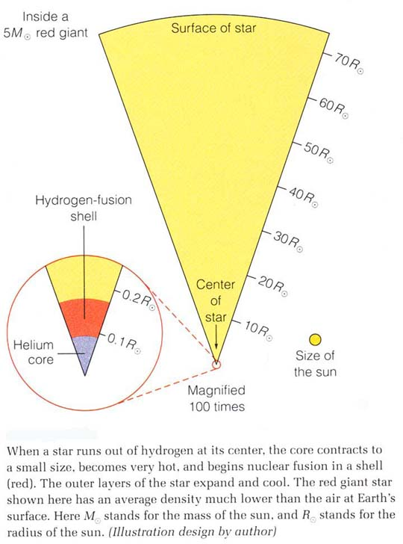

Helium nuclear fusion. Occurs by triple alpha process whereby three He-4 nuclei combine in a two-step process to form carbon-12 plus some energy.
[The lucky placement of a “resonance” without which there would be no carbon or anything heavier is discussed in class.]
This reaction requires T~100 million degrees K, which the core has attained by its contraction and heating. But for low mass stars (less than about 2 Mo), when the He gets hot enough to ignite, the core is so dense that the gas is degenerate. (This is an important concept, and will recur when we describe white dwarfs, and later neutron stars.) Only a brief description is given here.

Electron degeneracy pressure—due to quantum effect called “Pauli exclusion principle.” Result is that pressure does NOT depend on T, so He ignition increases T, which increases reaction rate, which increases T, … but pressure does not decrease in response ⇒ runaway “helium core flash” (see p. 533): energy gets soaked up by the huge “buffer” of the envelope, so virtually unobservable from the outside—but very well established theoretically—note how almost all of this is stellar evolution theory).
Eventually (after only a few hours or less), the huge energy input does cause the pressure to increase enough so that the core expands, making itself non-degenerate; it settles into a new equilibrium between pressure and gravity converting He into C ⇒ called “horizontal branch” phase, or just “core He burning.”
In effect, the star is given a new chance to resist gravity but for a shorter time than when it used H (He isn’t as efficient a fuel).

Depletion of He in core. He ⇒ C ashes. T too cool to burn C (requires 600 million degrees K!), so core contracts (like after H depletion), heats, ignites He-burning shell. So in this phase have double shell burning (H and He—see Fig. 20.6). Actually get repeating “shell flashes” (again, all theoretical). The outer layers expand continuously during He shell burning, just as for the 1st red giant phase, so the star becomes even bigger and more luminous.
This 2nd ascent of the red giant branch ⇒ “asymptotic giant branch (AGB)”.
Now the carbon (He ashes) core becomes degenerate before C can ignite (if original mass of star is less than about 8 Mo), and the temperature stops increasing ⇒ no more nuclear burning possible. (Remember this is only for low-mass stars.)
The star is near death now, in the sense of having no more nuclear fuel it can burn.
Students should be able to describe the evolution just described as an “evolutionary track” in the H-R diagram.

The HR diagram below shows theoretical evolutionary tracks for low-mass stars of different masses, from 1 to 9 Mo. (9Mo is already just outside of our adopted range for “low-mass” stars.)

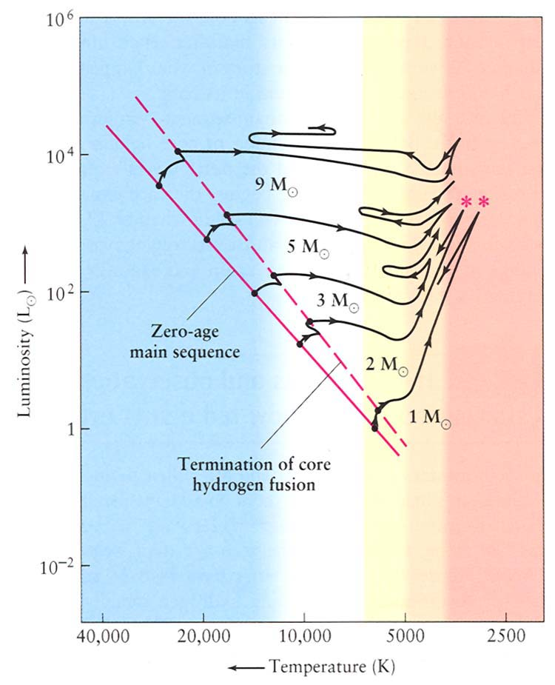
Further evolution of low-mass stars:
Planetary nebulae, white dwarfs
During the entire RG and AGB phases, significant mass loss is occurring (observed) by a wind. (Probably the radiation pressure and shock waves from pulsations driving matter away—see Discovery 20-2, p. 564.)

The star is also pulsating (period ~years); see Fig. 20.9. These bloated envelopes are not very stable! Eventually so much of the envelope is lost that the last bit of envelope gets ejected as a more or less spherical shell of gas called a planetary nebula. (see pretty images, pp. 538-539) (Note: “planetary” has nothing to do with planets; just a historical term.)

What remains, the degenerate hot core, now unveiled, is a young white dwarf, which will just cool and fade forever (unless it receives some new mass from a binary companion…) Your textbook calls a white dwarf that has faded a lot a “black dwarf.”

Since these objects just contain the products of helium-burning, white dwarfs should be composed mainly of carbon (and some oxygen, depending on how far He-burning proceeded). How might you test this prediction?
This is what happens to all low mass stars, by which we mean initial total masses less than about 8Mo. The sun will end its life this way.
Shown below is an illustration to help remember the phases of evolution and the internal structure of a low-mass star (like the sun).

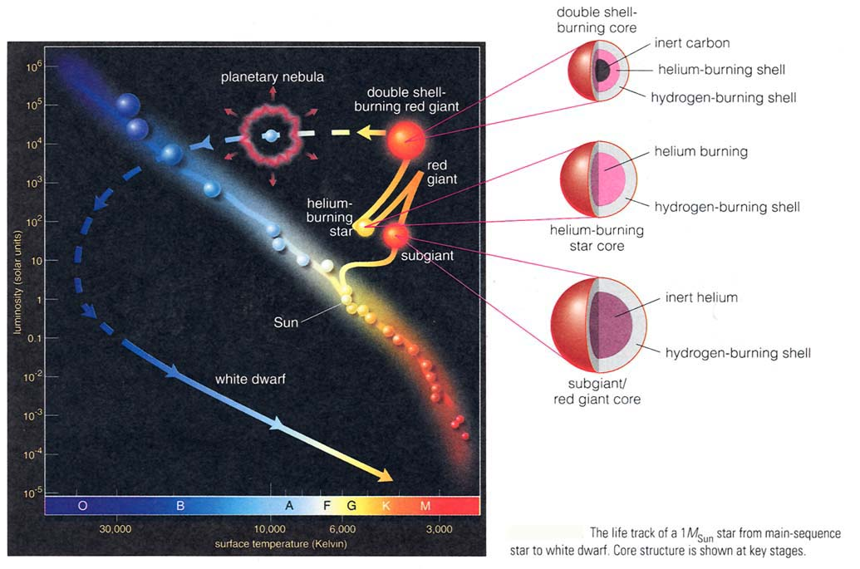

[Note: Section 20.6 on Stellar Evolution in Binary Systems will not be covered on the exam, but it is a fascinating subject—see the “symbiotic stars” in figures 20.22, 20.23.]
The following HR diagram shows theoretical evolutionary tracks and points representing observed stars, showing how the theory described so far can account for the observations.

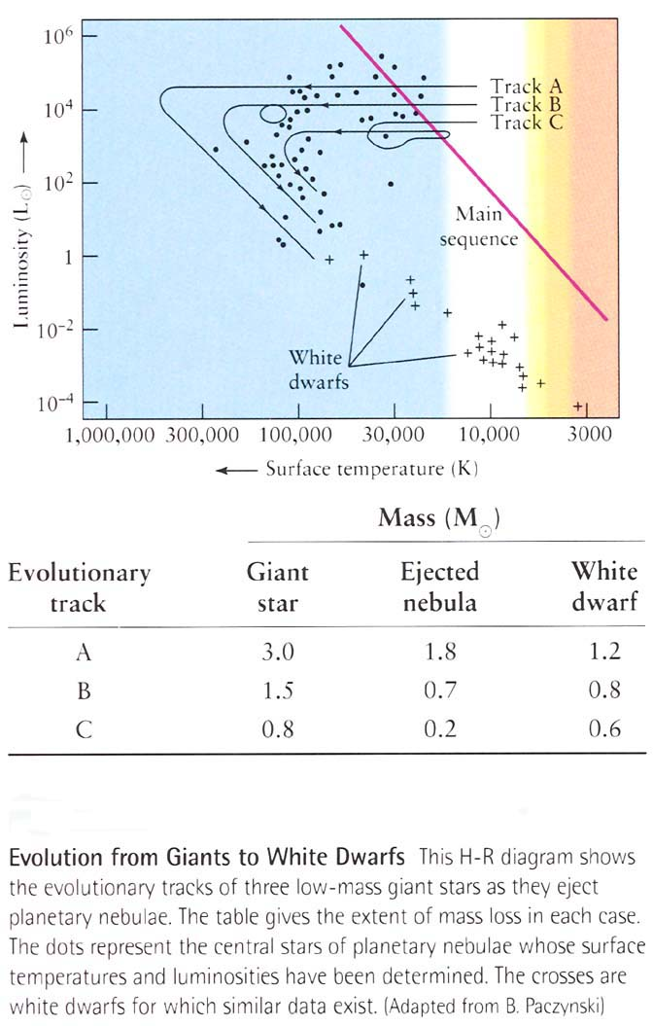

Evolution of high-mass stars
(Sec. 20.4) Evolution is similar to low-mass stars, except:

1. They evolve more rapidly through all phases (because they have huge luminosities to support, and are hotter in their cores).

2. Their central densities are lower, so never get degenerate. This means they can keep burning the ashes as new fuels:

H → He → C → O → Ne → …

The star will have an “onion skin” interior, with the heavier “ashes” closer to the center. During this burning the stars cross the H-R diagram horizontally, sometimes with loops (see Fig. 20.16).
Another illustration of this structure is shown below. See also the “cutout” illustration in Fig. 21.5—a massive star just before it explodes! We will come back to this.

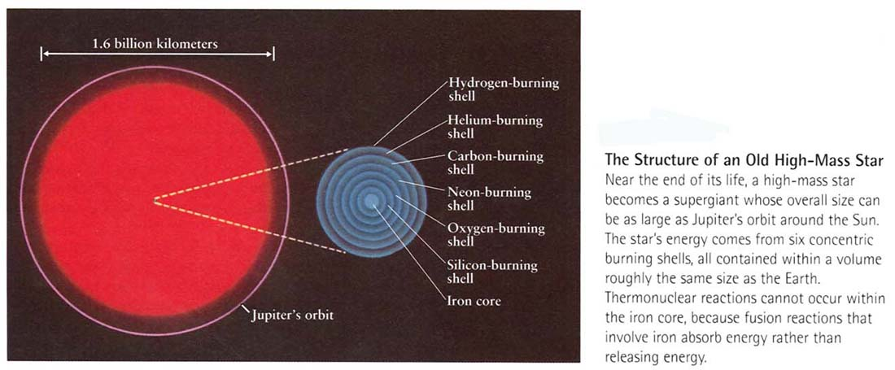

High-mass stars do lose mass, and if they lose enough, their mass at the time the carbon core forms could be small enough to result in a white dwarf. But it is believed that most stars more massive than 8-10 Mo cannot be “saved” as white dwarfs, and instead find themselves with a very different fate… (supernovae, neutron stars, black holes). This is covered in detail in subsequent chapters.

Observing Stellar Evolution in Star Clusters (sec. 20.5)
An intro. to this is sec. 19.6 which you should read again now. Read sec. 20.5 carefully and understand the H-R diagrams of open and globular clusters and their significance. We covered this in class in connection with sec. 19.6.
Extremely important question for you to think about: Why do open cluster HR diagrams have a variety of turnoff masses, while globular clusters all have a turnoff mass around 1 Mo? How is this related to the low metal abundances in globular clusters? The answer to this is the first hint for how our Galaxy formed.

