NEUTRON STARS, GAMMA RAY BURSTS, and BLACK HOLES
(chap. 22 in textbook)

We will review the classes of remnants that can be left behind a star at the end of its life. We have already discussed the remnants of low-mass stars: white dwarfs. The following diagram may clarify, and is a useful review of stellar evolution.
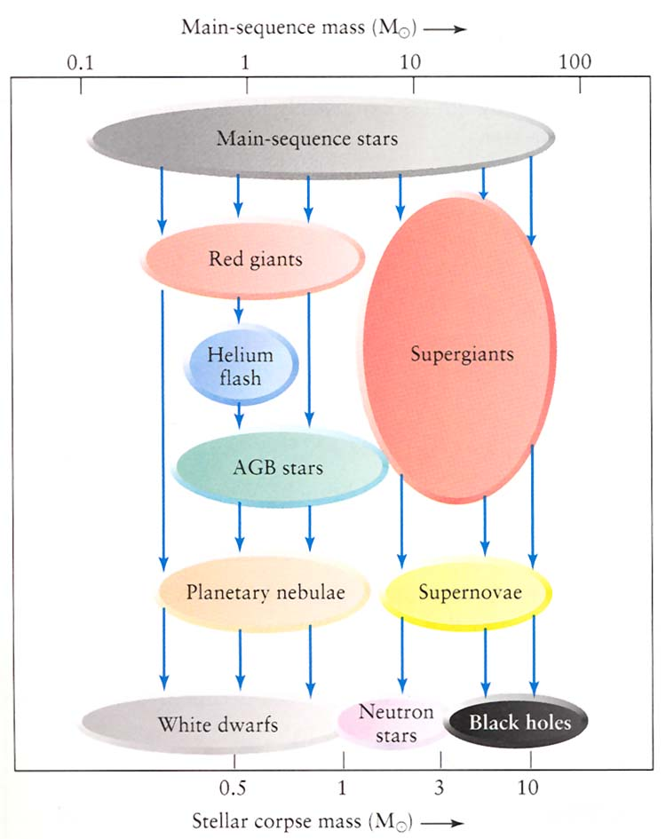

So we will discuss “neturon stars” and “black holes,” but in between we discuss the still mysterious “gamma-ray bursts.”

Neutron Stars

For carbon detonation SN ⇒ probably no remnant. The entire white dwarf explodes and disperses. A large fraction of it is turned into iron, and in fact this is believed to be the main supply of iron everywhere in the universe. (Recall that the light curves could be interpreted as the radioactive decay of two elements: nickel and cobalt. These will become iron.)

For core-collapse SN ⇒ remnant is a neutron-degenerate core
⇒ neutron star

Densities ~ 10¹⁴ to 10¹⁵ g/cm³ ~ billion times denser than water
Cubic centimeter contains ~ 100 million tons! Like a single enormous nucleus, all neutrons nearly touching. So they are very tiny for stars! (See graphic figure 22.1 in textbook.)

Gravity at surface is huge. e.g. a human would weigh ~ million tons

Rotation period ~ fraction of a second when first formed (conservation of angular momentum)

Magnetic field is huge, amplified by the collapse (~10¹² x Earth’s field strength). Most extreme of these are called “magnetars”—100s now known.

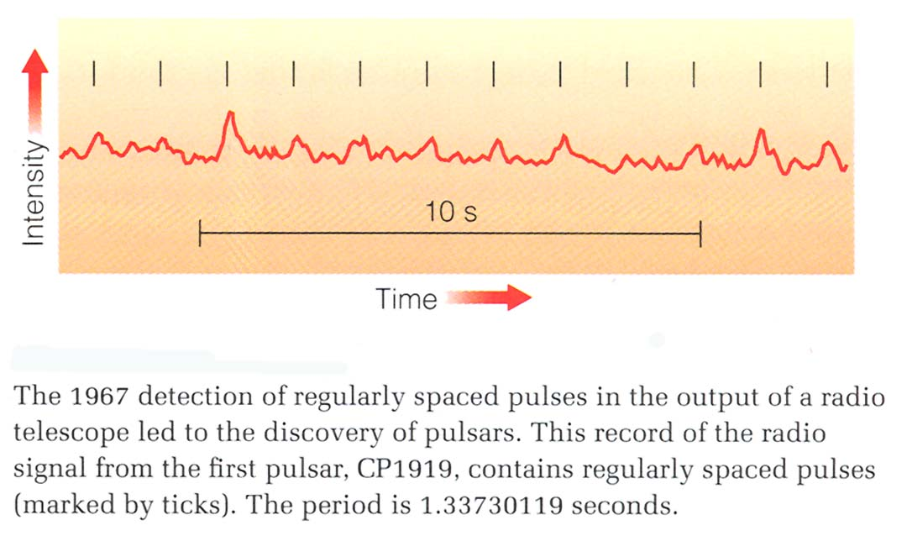
Observed as pulsars (discovered 1967). This was one of the most important astronomical discoveries of all time, by graduate student Jocelyn Bell, although her advisor was given the Nobel Prize for the totally accidental or serendipitous discovery.

The fact that a pulsar is observed right in the center of the Crab Nebula (see picture below) is taken as strong evidence that the picture of neutron stars as collabsed cores of massive stars that exploded as supernova remnants.

Each pulsar has different pulse period (0.03 to 0.3 sec for most) but most are very stable. (Fig. 22.2, and below.)

Here is another pulsar time series (“light curve”):

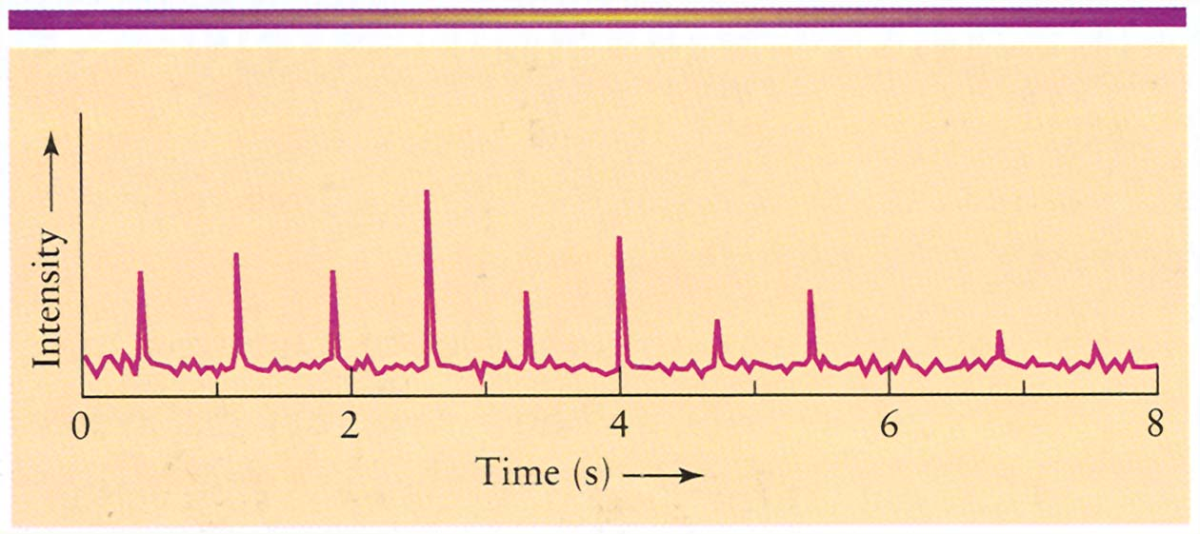

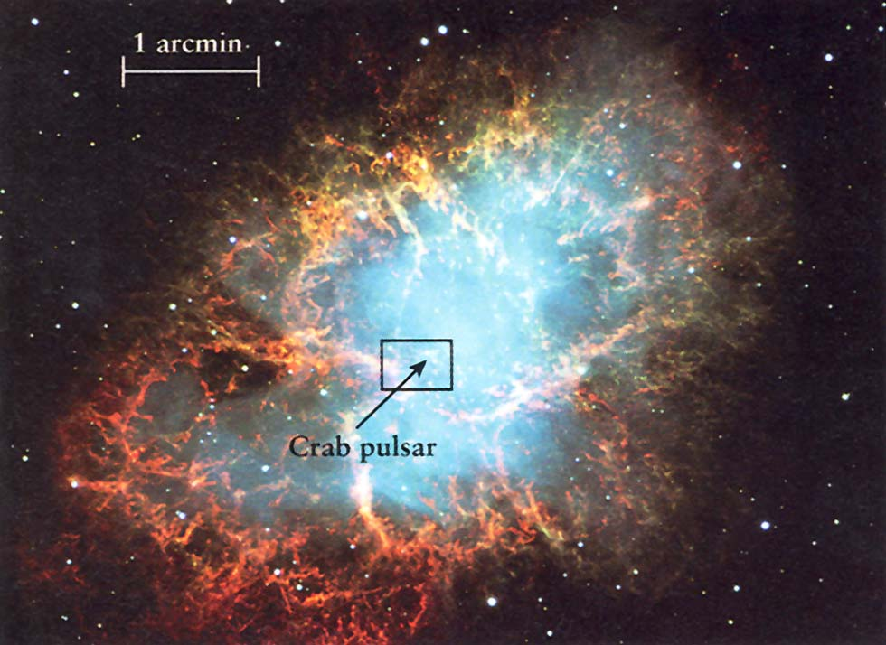
A few pulsars are seen within supernova remnants (e.g. Crab Nebula, Fig. 22.4, 22.5), which is very strong evidence that pulsars are neutron stars are remnants of supernova explosions, but not all remnants have a detectable pulsar. Reason explained below.

To understand neutron stars as “pulsars”, need to understand “accretion disks.” Mass transferred from companions star has orbital angular momentum, and can’t fall right onto the star, but must for a rotating disk, whose gas gradually loses angular momentum by not-very-understood processes: an “accretion disk.” These occur on every scale in the universe, around many objects (protostellar disks were one variety). Here is a picture of an accretion disk forming by mass transfer onto a white dwarf. This is in fact how we claimed white dwarfs could become supernovae, carbon detonation supernovae.
Interpretation: rotating “lighthouse model.” (Fig. 22.3) Rotation slows down with time, on a timescale of about a million years.
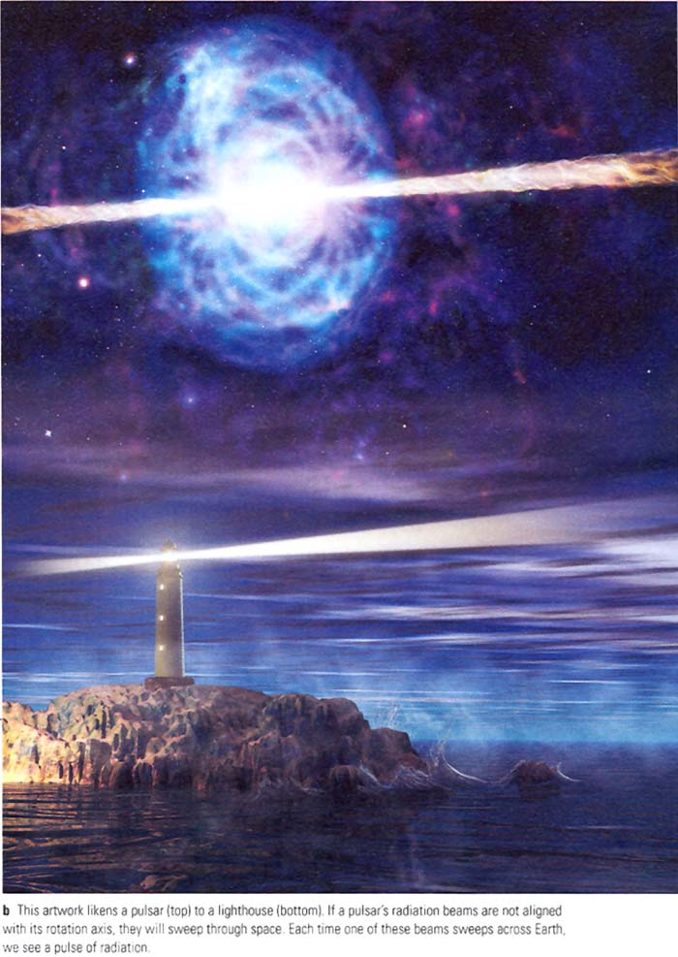

Understand why, in this model, not all neutron stars can be observed as pulsars.

“Glitches” (not in text) –sudden change in period probably due to “starquakes”.

Neutron stars in binaries (sec. 22.3)
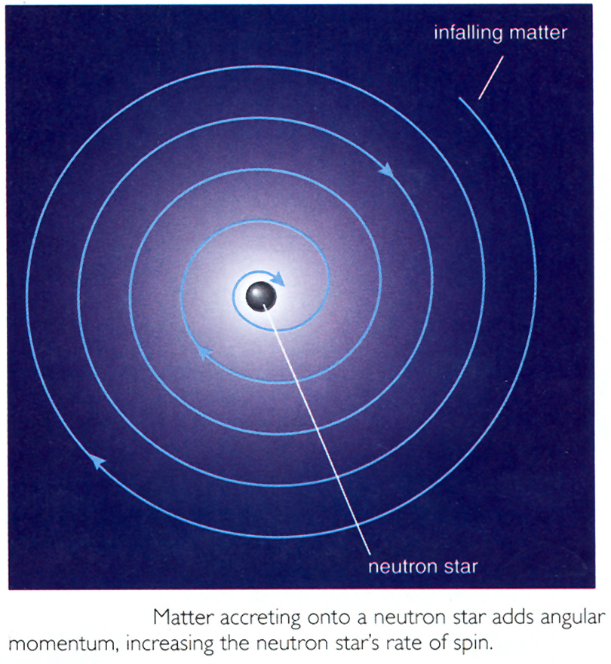
- x-ray bursters—neutron star accretes matter from main sequence or giant companion. Get accretion disk, heating at surface ⇒ fusion of H ⇒ outburst of x-rays lasting only a few seconds (analogous to novae, but much more violent)

Where did the binary companion go? See Fig.22.11 on p.588 for a possible and strange explanation.
SS443—Some material being shot out in jets at 25% the speed of light! See Fig. 22.8.

2. Millisecond pulsars—Periods ~ few x 0.001 sec. Spinning 100s of times per second! Found in globular clusters! (Fig. 22.9) Unexpected because pulsars should slow down and fade in millions of years, while all globular clusters are more than 10 billion years old!) So very old.
Interpretation: Neutron star spun up by accretion from binary companion (closely related to x-ray bursters, which may be on their way to becoming millisecond pulsars). See Fig. 22.10.

Pulsar planets (p. 588 in text)—1992: Pulse period of a millisecond pulsar found to vary periodically ⇒ planet in orbit around pulsar. Pulses arise earlier and later, depending on what part of the orbit the pulsar is in.

Notice that this method of detection is not like any we encountered when we discussed extrasolar planets. This technique relies on the fact that you have a very accurate clock (the pulses) to track the variation in light travel times,.

Now evidence for three planets orbiting this pulsar, with masses like that of the Earth! But almost certainly not primordial (there from the beginning), because planet would be destroyed by the supernova explosion that gave rise to the neutron star.

So maybe it is easy to form terrestrial-mass planets, if they could form in a violent explosion!

Gamma Ray Bursts
(sec.22.4)

Known since 1970s—brief (~10 sec) highly irregular (see Fig.22.12) flashes of gamma ray light. Until about 1995, no one knew what they could be or where located—solar system? Nearby stellar event flare? Need distance to get brightness (luminosity).

First indication: they are distributed isotropically in the sky (no preferred direction, like the plane of the Milky Way if they were in our Galactic disk). But they could be in the Oort comet cloud surrounding our solar system, or in the halo of our Galaxy, or…

Then in 1997 it was possible (from the Italian-Dutch BeppoSAX satellite) to see the x-ray “afterglow” from a gamma ray burst to locate its position in the sky more accurately, and then see spectral lines in its optical “afterglow.” The resulting Doppler shift was a redshift and it was enormous. As we’ll see later, because the universe is expanding, redshift can be used to get distance. Resulting distance for this gamma ray burst was 2 billion parsecs!

By now we have seen ~10 afterglows from gamma ray bursts (and their parent galaxies) and they are all extremely distant ⇒ extremely luminous. In fact more energy produced than a supernova, and all in a matter of seconds! Probably most powerful objects in the universe.

What are they?? A hint is that they flicker on timescales of a hundredth or thousandth of a second, which means they can’t be larger than a few hundred kilometers across. (See p. 590 for the important explanation of this effect, which gives us limits to the sizes of objects just from how fast they flicker.) How could so much energy be generated in such a small object??

There is much evidence that these outflows are relativistic (i.e. moving near the speed of light) expending fireball jets. Their outflows are “beamed,” but don’t confuse this beaming with that of neutron stars—they are probably due to completely different mechanisms.

But what causes them? Leading theories:

1. Coalescing neutron star binary.
2. Hypernova—some evidence for this because of probable association of 1998 supernova with a gamma ray burst. Actually these may just be supernovae in a particular mass range, since the rate of supernova explosions far exceeds that of gamma-ray bursts.
See discussion and sketches of these models on pp. 578-579. We will discuss briefly in class.

But really, no one knows, and it is one of the biggest challenges for theoretical modelers. Recent evidence supports the idea that the short-duration bursts ( ~ few seconds) are best explained as coalescing neutron stars, while the longer-duration bursts are probably exploding stars.
Currently a new generation of space-based and ground-based (robotic) survey devices are discovering new gamma ray bursts at an astronishing rate.

Black Holes (sec. 22.5-22.8)

For stars: if mass of core greater than about 3M_{o}, neutron degeneracy cannot prevent collapse ⇒ “black hole” singularity.

Event horizon = distance from BH within which even light cannot escape (also known as “Schwarzschild radius”). This is not size of black hole itself (in principle infinitesimal radius, infinite density).

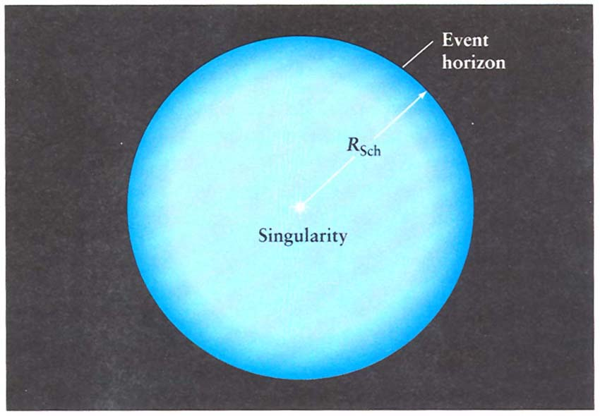

Object falling into BH:

1. Matter falling toward BH is stretched and squeezed by huge tidal forces ⇒ heating to x-ray temperatures (this will be one way to indirectly detect BHs.
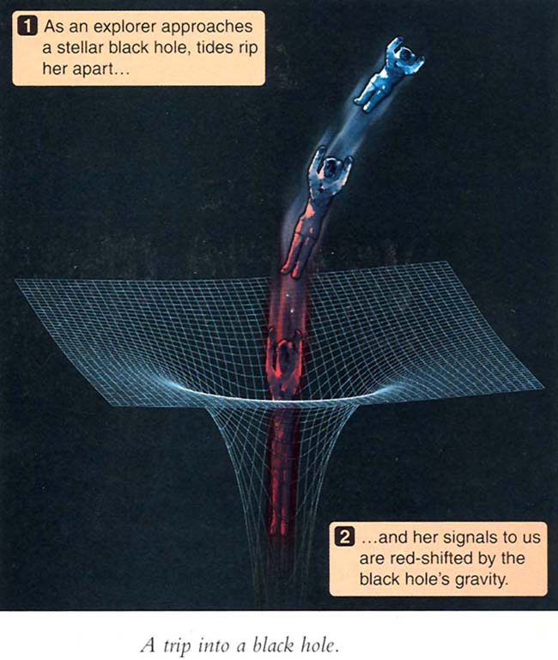
2. Gets redder due to gravitational redshift. This is not Doppler shift; it occurs because time slows down (see below), and a light wave is like a clock. Or can interpret this redshift as energy used by photon trying to get out of the increased gravitational “well.” (See illustration later. But remember, the photons still travel at the speed of light.)

- Appears to slow down, then freezes at event horizon due to “time dilation.” (We’ll return to this below.)

Most of the strange effects near a black hole are just phenomena predicted by Einstein’s theory of relativity, but at extremely strong gravitational fields. The main effects:

Curved paths of light ⇒ gravity distorts space so shortest paths are not straight lines. Well-verified experimentally (e.g. deflection of starlight passing near sun).

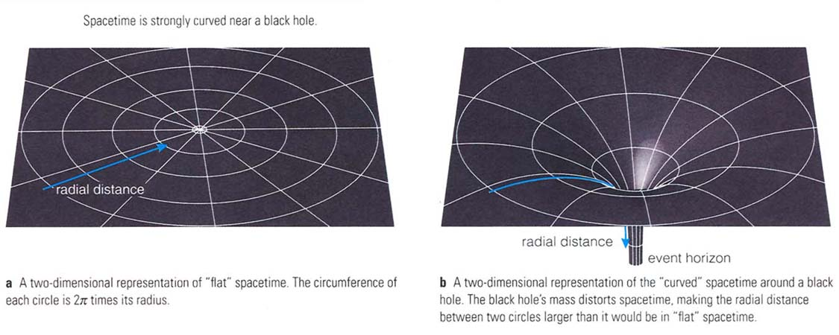
Time slows down in gravitational field. Tested in 1959 (using physics building at Harvard), and then from aircraft, space flights. For sun’s effect, Viking spacecraft (1976) sent pulses of radio waves toward Earth that passed near the sun.

Detection of Black Holes

In binary systems: For stellar-mass black holes, strong evidence for existence of BHs comes from spectroscopic binary star systems with an invisible companion of mass greater than about 3Mo.
Best candidate: Cygnus X-1. Three main lines of evidence;
1. Visible companion has mass around 25Mo. Using the known period and the primary star’s orbital speed from the radial velocity, get sum of masses, and hence mass of invisible companion: about 10Mo ⇒ must be black hole (assuming theoretical calculation of neutron star/black hole mass limit is ok).
2. Hot x-ray emitting gas is observed flowing toward the invisible companion. This is consistent with a black hole, but it would also be consistent with a neutron star.
3. Small duration of x-ray variations (about 1 millisecond) implies size less than about 300 km ⇒ could be neutron star or black hole.
So can see that only (1) above unambiguously identifies the invisible companion as a BH.
Two other good candidates: LMC X-3 (mass of invisible companion about 10 Mo) and A0620-00 (mass about 3.8 Mo).

Note that BHs in binary systems may provide our best chance to detect gravity waves, a major prediction of Einstein’s theory of general relativity that has been impossible to verify directly because it is an extremely small effect. Read Discovery 22-1 in your text on this subject; what is the result that most astronomers consider as an indirect confirmation of the existence of gravitational radiation?
Homework: search the web for current status of the LIGO experiment. Has there been a recent detection?

In globular clusters: Sept. 2002: UT astronomer Karl Gebhardt et al. discover intermediate mass BH in center of globular cluster. Now plenty are known.

At the centers of galaxies: Stars and gas very near the centers of galaxies (including our own) are moving very rapidly, orbiting some unseen object. Masses inferred from Newton’s laws are millions to billions of solar masses! ⇒ supermassive black holes. This was uncertain until a few years ago, but now very accurate observations have confirmed the existence of these "monsters." Understand how we infer their presence simply from Kepler’s 3rd law as applied to a group of stars in orbit around “something.”

In young super star clusters in “starburst” galaxies like M82 (see pp. 605)—inferred BH masses thousands of Mo. These are inferred from presence of bright compact x-ray sources (i.e. consistent with accretion onto BH). These are “intermediate-mass” black holes, and they appear to have formed recently. No one knows how, but collisions and coalescence between massive stars in these dense clusters is one possibility.

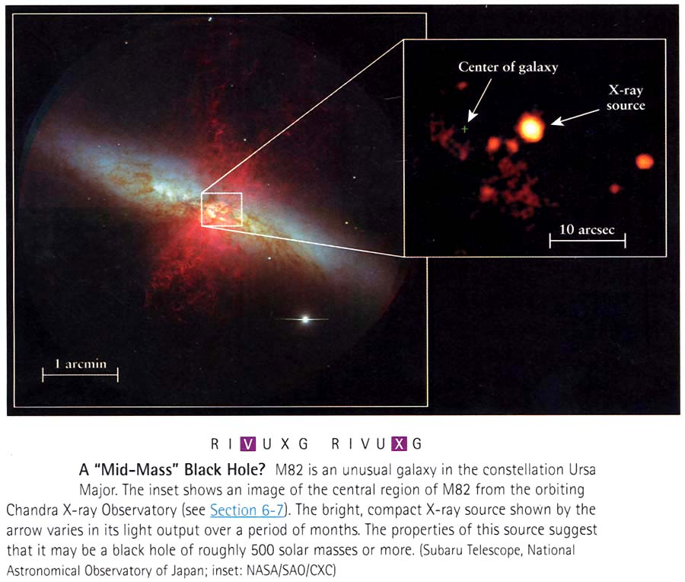

So we see evidence for BHs all the way from stellar masses to billions of solar masses.

Detection of an event horizon? Previous edition had mention of the “decaying pulses from blob” that had been interpreted as evidence for an event horizon. Still in this edition? Can you find it on the internet?

[Additional topics below will NOT be covered on exam.]

Rotating black holes: singularity is a ring! BH drags space-time around with it. Could accelerate a star ship by whipping through the “ergoregion” outside the event horizon.
Wormholes: time travel, baby universes (“multiverse”) possible.
___________________________________________________
Visual review (again) of all of stellar evolution and how it depends on the initial mass of a star:

