Notes on Ch. 23 and 24.

The Milky Way Galaxy (ch. 23)

[Exceptions: We won’t discuss sec. 23.7 (Galactic Center) in class, but look it over in order to just get the most basic point—I might put a question or two on the exam to make sure you have looked at this interesting material. There will be several sections that we will have to treat this way.]
In following lecture outline, numbers refer to the Figure numbers in your textbook. In this draft they have not been revised to reflect the new edition.
A basic theme in this chapter is how it was gradually discovered that our Galaxy is not the whole universe, but that instead, if we could view it from the outside, our Galaxy would look something like:

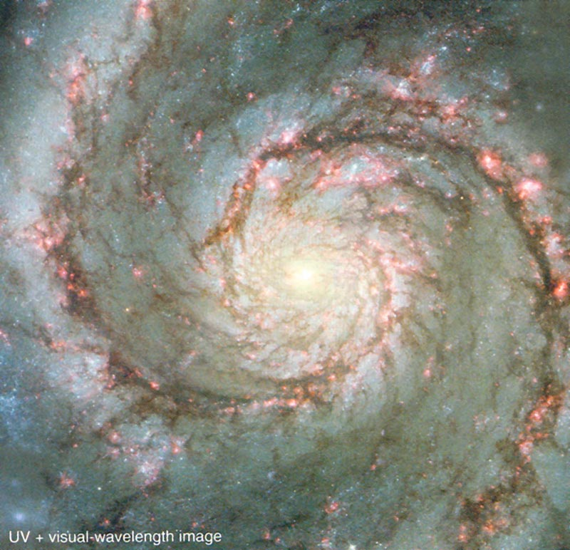

Think about the problem of getting a characterization of the nature of the surface of the earth while standing within a forest. In the Galaxy case the trees are dust grains, preventing us from seeing outside our local neighborhood (at visible wavelengths or smaller). But even using light of longer wavelengths, there is a big problem: how do we get accurate distances to the objects too distant to use trigonometric, or even spectroscopic, parallaxes? [Make sure you can explain spectroscopic parallax so that you don’t forget the general approach to getting distances, which we will begin to encounter at a rapid rate.]
One thing we can tell by just looking at the pattern of stars and gas in the sky: our Galaxy must be flat. Look at the images of the sky at different wavelengths (similar to an image in your book):

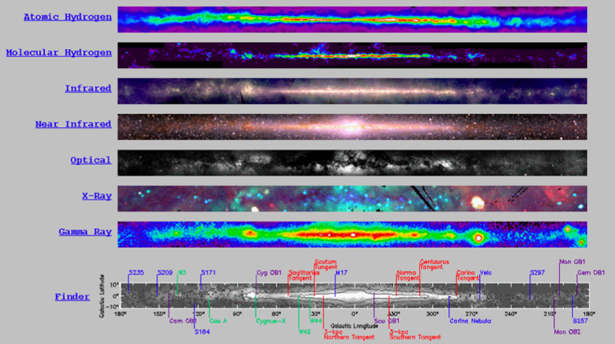

But how do we know that this disk doesn’t extend for a thousand, or a billion, parsecs?

What about applying spectroscopic parallax to all the O and B stars we can see (think: why use these stars? I will ask you this on the exam). Here is a schematic of the result:

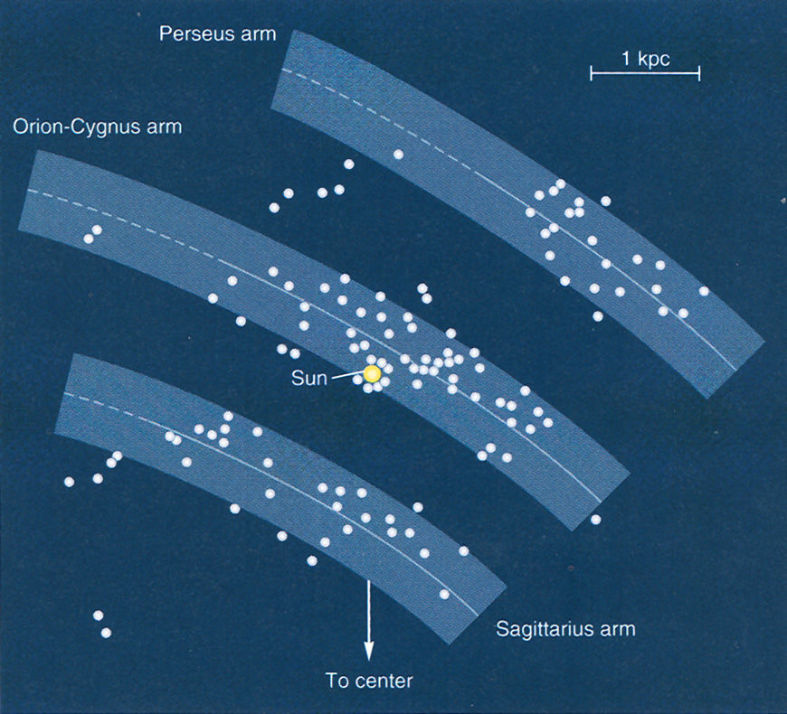

In hindsight, we interpret this as seeing parts of the spiral arms of our galaxy, but until around 1950-1960 the calibration wasn’t good enough to see this, and even when we could, there are still these important questions:
 How far does this disk extend? Is it round, elongated, … ?
 Is our Galaxy made of bands in a disk, or is there more? What is the shape of the distribution of the young and old stars?
 Our there other galaxies like ours?
Answers to these questions require distances using the next “standard candle”: variable (pulsating) stars.

Finding our position in the Milky Way (MW)—Counting stars in different directions is very misleading (23.4). Instead, the breakthrough came from using RR Lyrae stars to get the distances to globular clusters (23.9).

There are two kinds of variable stars (their apparent brightness varies periodically because they are pulsating) that are used as “standard candles” for distance estimates:

a. RR Lyrae stars—all have similar light curves, periods 0.5 to 1 day (23.5), and all have approximately the same luminosity! (Think about how handy this is—see 23.6.).
Only low-mass metal-poor stars become RR Lyrae stars, so these gave distances to globular clusters (think: old, metal-poor), showing that we weren’t located at the center of our Galaxy, and that the Galaxy has a roughly spherical “halo.” (23.9)

So we already have an answer to part of question 2 above: The oldest stars in our galaxy are distributed in space in a roughly spherical halo, consisting mostly of the globular clusters. This tells us that, since these stars are all old and metal-poor, our Galaxy probably began its life as a roughly spherical cloud, and later flattened into a disk.

[Later we will see that there is a much more massive “dark matter” halo that is actually most of the mass of our Galaxy—yet we can’t see it and we don’t know what it is made of!]

b. Cepheid variables—periods 1-100 days; they show a very tight period-luminosity relation (23.7), which can be used to get their distances. Important because they are much brighter than RR Lyrae stars, so can get distances to the nearest galaxies using Cepheids.

These two methods form the next rung of the ladder of “standard candles” of distance indicators that we will eventually extend to map the structure of the whole universe. Make sure you understand the relation between needing distances to things in order to make a map!

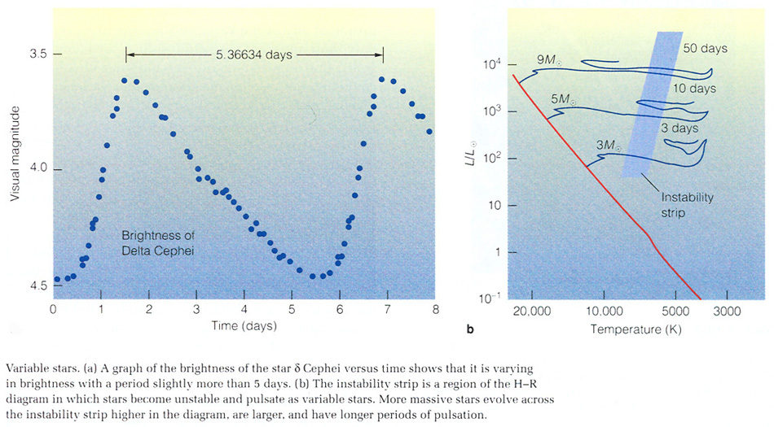

The above illustration shows a light curve for a Cepheid variable (left); this is all we need to measure in order to find that we are looking at a Cepheid. The H-R diagram on the right shows the “instability strip” where all the Cepheids are found—it turns out that the envelopes of stars in this band are unstable to radial pulsations.

Consider how lucky we are that there are pulsating stars that can be used to get distances. If not for these stars, we might not have discovered that there are other galaxies (e.g. our nearest neighbors, Large and Small Magellanic Clouds [LMC, SMC], and Andromeda) until much later in this decade.

Our galaxy’s “stellar populations”: Disk, halo, and bulge. Properties to discuss and understand (see also table 23.1):
Spatial distribution (23.10)
Color
Age
Metal abundances
Orbits (23.13)

The illustration below shows how the disk and halo stellar populations of our Galaxy are distinct in their spectra, with the halo stars having weaker spectral lines than disk stars of the same temperature (spectral type).

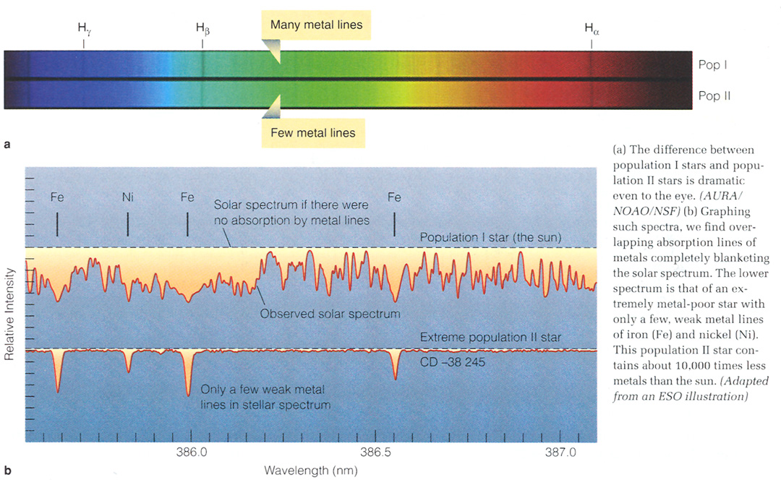

The following illustration shows the different orbital characteristics of disk and halo stars.

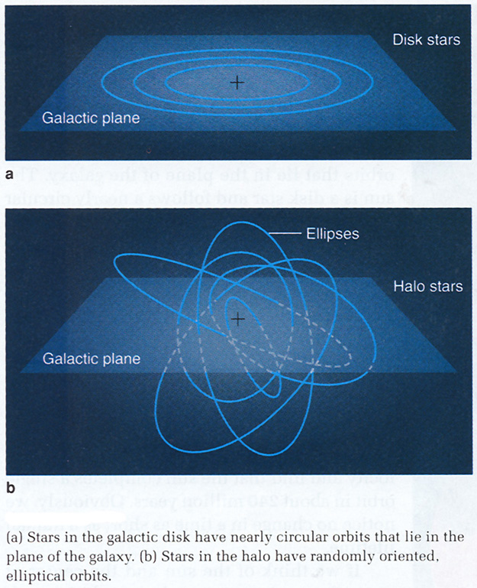

These population characteristics suggest a consistent picture for the formation and evolution of our galaxy (Fig.23.14)—halo forms first in nearly spherical shape, rest of gas collapsed to disk which has formed stars continuously since that time. (Think about how above properties suggest this.)
More recently it was discovered that our Galaxy has a weak but detectable bar structure in the bulge. This rotating bar is important, because it keeps things “stirred up” through its gravity, and might even drive density waves (see below; but material on density waves will not be on the exam).

Mapping the disk—can’t use stars except nearby (why?); must use radio HI and CO spectral lines for more distant regions. Result from radial velocities and distances: differential galactic rotation (23.12). Inner parts rotating faster than outer parts (at least at our distance from the center—see below). Note that this is just for the disk—the halo stars are moving differently (see 23.13).
Here is an illustrative HI map of our Galaxy.
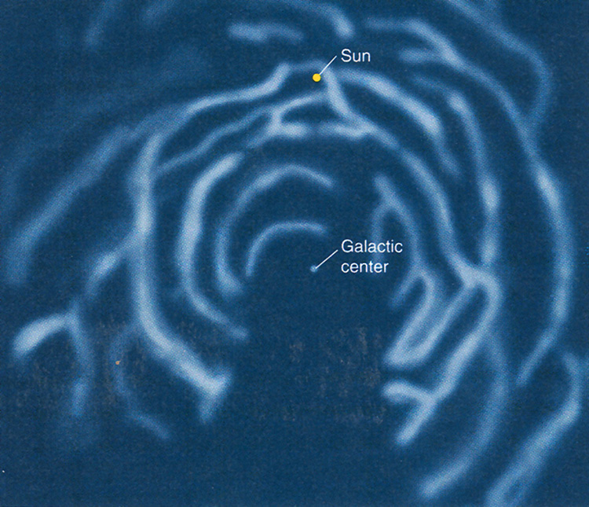

Spiral structure – These maps show evidence for spiral arms (although these can be seen more clearly in other galaxies, e.g. 23.3). How can spiral structure persist? If they were material structures, differential rotation would wind them up very tightly (23.17).
Two theories, probably both contribute:

a. Spiral density waves—spirals are only wave patterns moving through the disk. (Think of sound waves—the gas itself doesn’t move from one place to another.) Gas passing through wave is slowed down and compressed, get enhanced star formation (23.18 and Discovery 23-2).

b. Self-propagating star formation---Star formation at one location causes explosions that compress the gas some distance away, causing more star formation, and the process repeats, spreading through the galaxy. Makes spiral pattern in differentially rotating disk. (23.19)

The origin and maintainance of the spiral is only a problem for a), not b). But a plausible answer for (a) is: waves are “excited” by gravitational interactions with galactic neighbors, or by a “bar” within the bulge of our Galaxy and others.

The topics on this page, theories of spiral structure, will not be on the next exam.

Another possibility, not mentioned in the book, is that the arms could be generated by the bar that is located in the central regions of the galaxy. Here is a simulated IR map of our galaxy showing the bar and the ring it definitely produces.

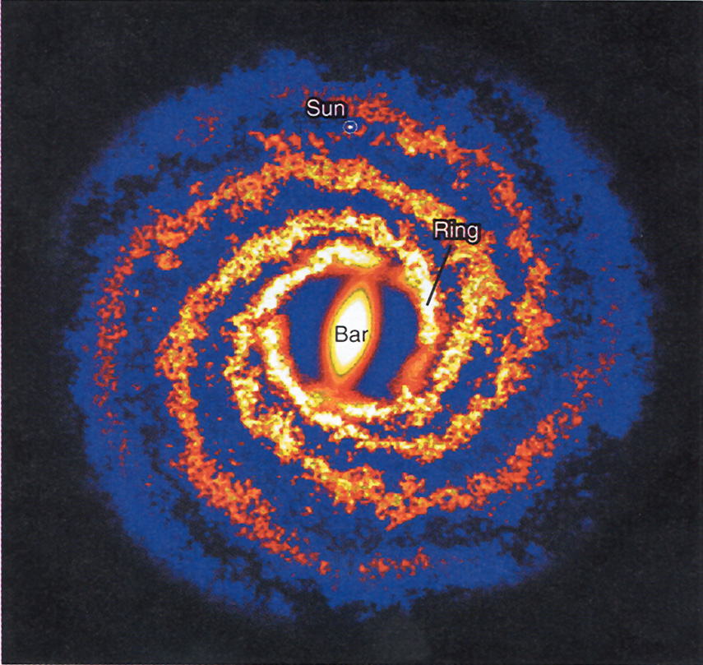

Mass of our Galaxy: Use rotational speeds of stars around galactic center to infer how much mass is inside of that orbit (23.20):

Total mass = (orbit size )³/(period)²

this is just Kepler’s 3rd law—remember?)

This use of orbital speeds is called the rotation curve of a galaxy (23.21). We expected speeds to decrease as you get further from center of galaxy (like planets in the solar system, so called “Keplerian rotation curve”). Instead the rotation curve outside a certain distance from the center becomes flat ⇒ stars moving faster than can be accounted for by the observed mass ⇒ dark matter, probably in the form of a halo. Nobody knows what dark matter is, but a few possibilities have been ruled out, and one or two are still possibilities.

Candidates for dark matter:
Faint red stars or brown dwarfs—can now rule this out. (p. 623).

Faint white dwarfs—can almost rule this out; gives less than about 10% of what is required (not half, as stated in the text).

Can test for these types of objects using gravitational lensing (Fig. 23.23). Must observe millions of stars every few days over a period of years, bcause the flickering should be very rare.

Exotic particles—some theories of particle physics predict there should exist a zoo of these massive particles, but we have no idea which ones could be the dark matter. But most astronomers think these “WIMPS” (weakly interacting massive particles, p. 624) are the most likely candidate.

Our galaxy: A disk and halo of light-emitting matter (disk, bulge, halo) within a dark matter halo, which is much larger than the disk or halo of stars.

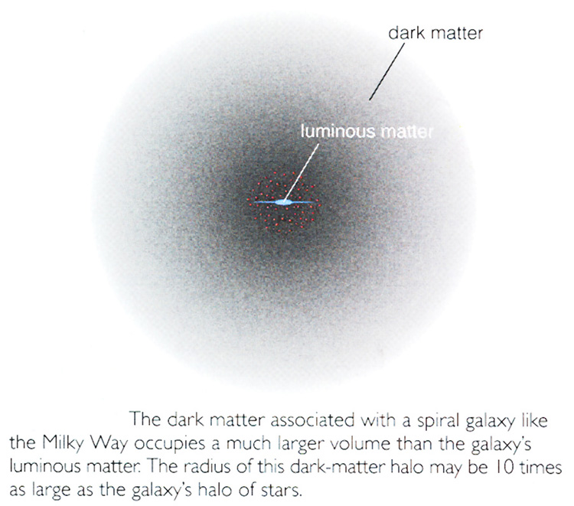
Normal Galaxies (Ch. 24)
Here we will cover topics in Ch. 24 up to 24.4, but then skip 24.4, 24.5. The sections we are skipping are all about processes that occur in the centers of galaxies, so I’d like to keep that separate from the logical progression that leads us from the local galaxies to the large-scale structure of the universe. Please look it over yourself if interested, but it won’t be on the exam.
In the outline below, figures are referred to by number alone: e.g. 24.12 is Figure 24.12 in your book.

Hubble sequence—galaxy classification scheme, originally based on appearance, but correlates with other properties as well.

Symbolically: E0….E7..…S0…..Sa..Sb..Sc..Sd…..Irr

Properties (see diagram discussed in class; also table 24.1)
Ellipticals: featureless—no disk or arms; no gas or dust (a few exceptions); huge range in sizes, from dwarfs to giants; yellow-reddish in color.

S0s: Disks, but no gas or spiral arms. So intermediate between Es and spirals.

Spirals: Flat disk with spiral arms, central bulge. Sequence Sa,…Sd corresponds to increasing size of bulge, increasing tightness of arms, and more gas mass relative to stars. Also parallel sequence of barred spirals.

Irregulars: Tend to be smaller than spirals. Many are dwarf irregulars (dIrr). Often found as satellites (e.g. Magellanic Clouds). Blue color, lots of gas.

Masses of galaxies: From 10⁶ to 10⁷ Mo (dE and dIrr) to 10¹² Mo (giant Es). The smallest are the most numerous galaxies in the universe. (How do you think we get masses of galaxies?)

How are these different kinds of galaxies distributed in space?

Groups of galaxies— We can use Cepheid variables to make a map of our “local” galactic neighborhood (can get distances out to about 15 Mpc).
Our Local Group—About 50 galaxies within about 1 Mpc (=1000 kpc = (roughly) 10 x size of our Galaxy) of each other. Most of the mass is in the large spirals Milky Way and Andromeda. Most of the galaxies are dE and dIrr galaxies. Many are satellites of larger galaxies (e.g. 3 satellites of Milky Way are LMC, SMC, and Sgr dwarfs, a few others that are more distant; Andromeda has several small satellites) Look at Fig. 24.13.

To get to larger distances, must use brighter standard candles. The next one in the ladder of standard candles is the Tully-Fisher relation ⇒ very tight relation (for disk galaxies) between rotational velocity (from broadening of galaxy’s spectral lines—see Fig. 24.11) and luminosity. (Think why this makes sense: the galaxy’s rotation is balancing its gravity, which is due to its mass, related to its luminosity…)
So for a galaxy too far away to use any other method, just obtain a spectrum (21 cm neutral hydrogen line is best) and measure width of line; the Tully-Fisher relation then gives you the luminosity, so (knowing the apparent brightness) you get the distance.
This method can be used out to about 200 Mpc ⇒ allows us to make a map of the relatively nearby universe.

Before looking at the results, there is one more rung in the ladder of distance indicators or standard candles, called the Hubble relation or Hubble’s law, to consider.
Hubble’s Law –this is the basis for our ideas about how the universe formed (the “big bang” theory), so important to understand it.
Using galaxies of known distance (e.g. using Cepheids, Tully-Fisher), find that velocity of recession (redshift) increases linearly with distance (24.16, 24.17). Indicates that universe is expanding.
Recession velocity = constant (H₀) x distance
The constant of proportionality is called the Hubble constant, which is a fundamental measure of age of the universe (next section of course—for now we just want to use it to get distances and map the universe).
See Fig. 24.18 on the “cosmic distance ladder.” You should understand what these different distance indicators are, and why each can only be used out to a certain distance.
[Textbook discusses active galactic nuclei, including our own, at this point, sec. 24.4 and 24.5; we are not going to cover that material, either in class or on the exam.]

