Chapter 25, 26, 27 Lecture Notes

This is for the material on the last exam.

Galaxies and Dark Matter (Ch. 25)
First review the Hubble law so that you are comfortable with the idea that redshift is the same as distance is the same as how long ago. You also have to be comfortable with the “distance ladder.” So here are some notes from the last exam material:
[Review from end of ch. 24]
Hubble’s Law –this is the basis for our ideas about how the universe formed (the “big bang” theory), so important to understand it.
Using galaxies of known distance (e.g. using Cepheids, Tully-Fisher), find that velocity of recession (redshift) increases linearly with distance (24.16, 24.17). Indicates that universe is expanding.
Recession velocity = constant (H₀) x distance
The constant of proportionality is called the Hubble constant, which is a fundamental measure of age of the universe (next section of course—for now we just want to use it to get distances and map the universe).
See Fig. 24.18 on the “cosmic distance ladder.” You should understand what these different distance indicators are, and why each can only be used out to a certain distance.
[Textbook discusses active galactic nuclei, including our own, at this point, sec. 24.4 and 24.5 but we are going to skip to Ch. 25 in our discussion; you should read sec. 24.4 and 24.5 on your own.]
______________________
Now go to sec. 25.5, The Universe on Large Scales, to continue along the same theme. We will not follow the material in the same order as in the book.

Mapping distances to more and more distant galaxies, we find that galaxies occur not only in small groups like ours, but in larger galaxy clusters. The nearest is the Virgo Cluster, whose center is about 20 Mpc away. It contains about 2500 galaxies, with a size of about 3 Mpc. We are located in outskirts.
But the Virgo Cluster is only one of many clusters which make up our local “supercluster” (see Fig.25.20, 25.21), which is about 100 Mpc in size.
Using the Hubble relation (sec. 24.3), we can get distances to galaxies even farther away if we can obtain their spectra, so we can get their redshift and calculate the distance from the equation above. The collection of redshifts for tens of 1000s of galaxies has taken many years on the largest telescopes, but now we have a good map of the universe out to about 1000 Mpc. The Sloan Digital Sky Survey will very soon provide redshifts for millions of galaxies! (See Discovery 25-1).
Some results:
Superclusters = clusters of clusters of galaxies. Our Local Supercluster is ~ 100 Mpc across, contains ~ 10,000 galaxies. See Fig. 25.20, 25.21.
Extending out to 200 Mpc (Fig. 25.22) and 1000 Mpc (Fig. 25.23) we see larger and larger structures, often huge filaments (e.g. the “Great Wall) and huge voids; the galaxies in the universe are apparently hierarchically clustered up to sizes of around 200 Mpc. (Remember the distance between our galaxy and our nearest neighbors is less than about 1 Mpc.)
So the universe as a whole is a frothy structure of filaments and bubbles surrounding low-density voids. We trace this structure with galaxy positions, but we know that most of it is actually the mysterious dark matter, whose gravity has apparently dragged the visible matter along with it into this structure.
See “map” on next page.

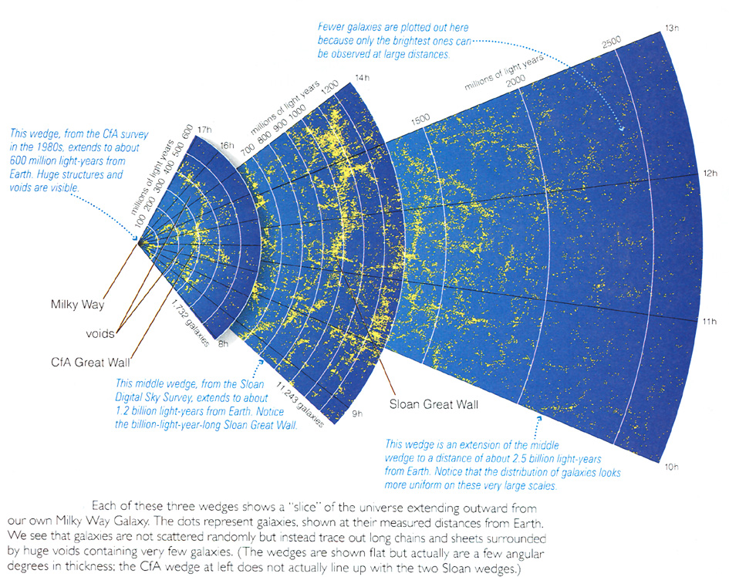

Evidence that most of the matter is “dark matter.”
So far we have concentrated on the distribution of galaxies in the universe, but let’s return to individual galaxies and clusters of galaxies to see what their masses are—we will find that we are only seeing the “tip of the iceberg.”
Masses of galaxies—rotation curves (Fig. 25.1; reread ch. 23.6 if you’ve forgotten this for our Galaxy) indicate ~ 30 to 90% of mass is invisible “dark matter” (i.e. masses come out about 3 to10 times larger than what we can see in any form). This is similar to what we found from the rotation curve for our Galaxy.
Illustration below is to review what a rotation curve tells us about the mass distribution in any system:

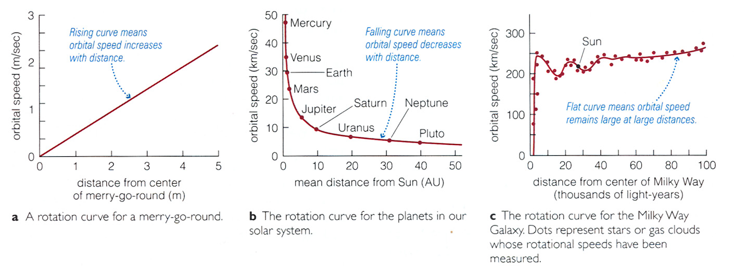

How do we get rotation curves for most (disk) galaxies? Neutral hydrogen 21 cm line and the Doppler effect:

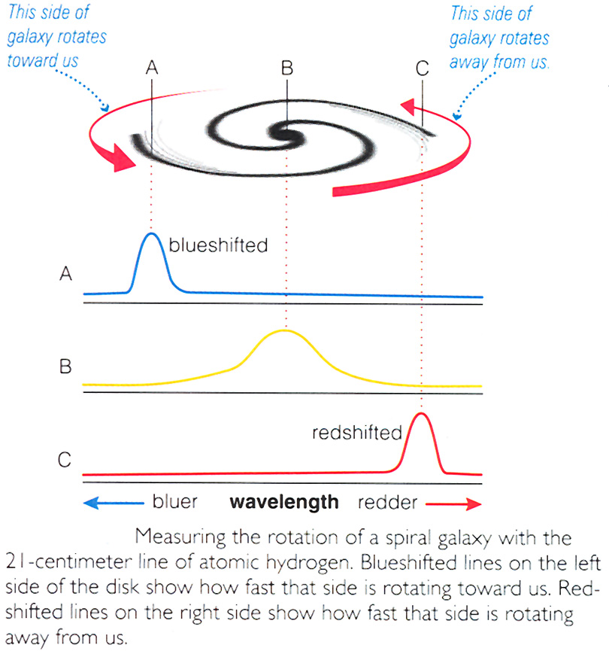

Result: Most disk galaxies have rotation curves like the Milky Way
→ dark matter dominates all galaxies that have been studied.

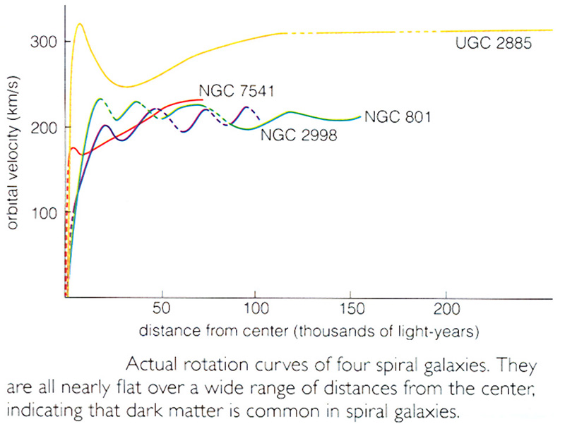

Masses of clusters of galaxies—from motions of galaxies in clusters (Fig. 25.2). Inferred masses again come out about 10 times larger than what we can see in galaxies. Some of the mass of clusters turns out to be observable in the x-ray part of the spectrum: clusters of galaxies are filled with extremely hot (tens of millions of degrees) gas. However the total mass of this “inctracluster gas” (images shown in 25.4 and 25.6) is only comparable to the mass of galaxies, so it doesn’t account for the inferred masses. Again we find that most of the mass is unseen “dark matter.” (Get about the same thing from estimates of masses of binary galaxies—see 25.2.)
⇒ must face fact that most of the mass of the universe is in a form we can’t see, i.e. that doesn’t emit light at any wavelength. What is it? See discussion earlier (sec. 23.6). Probably unknown exotic fundamental particles, but still uncertain.

Formation and evolution of galaxies (sec. 25.2 and 25.3 is very good on this subject).
Theoretical simulations and observations of galaxies very far away (and so when the universe was much younger) are giving a consistent (and surprising!) picture: That the first galaxies were small irregular objects that repeatedly merged in collisions to produce larger and larger galaxies (see Fig. 25.10).
Much of this comes from the observations known as the “Hubble Deep Field”—see Fig. 25.11 in text.
When two similarly sized disk galaxies merge, the product (in simulations) looks very much like an elliptical galaxy. (Not sure what fraction of ellipticals formed this way.) You can see the effects of galaxy collisions in the form of tidal tails (25.9, “The Antennae”) and ring galaxies (25.7, the “Cartwheel” galaxy). These images of real galaxies match the simulations of galaxy collisions very well (see right side of Fig. 25.9).
Here is a couple of examples of interacting galaxies. One might resemble our own galaxy’s interaction with the Large Magellanic Cloud.

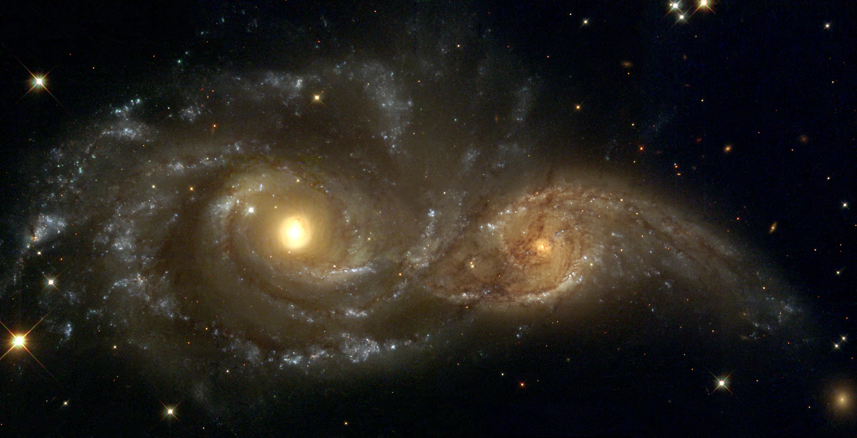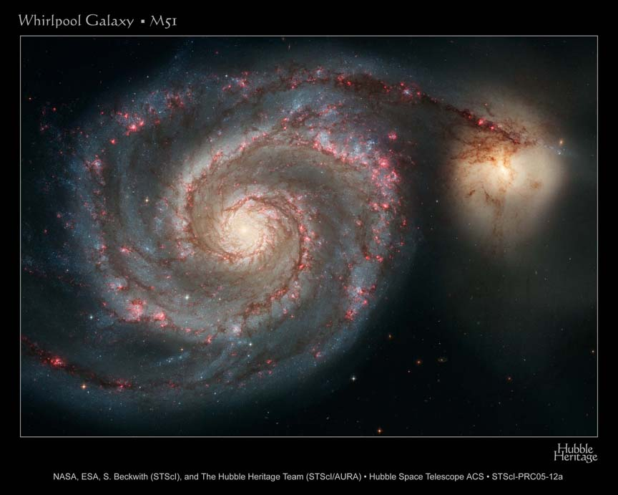

Most large galaxies have probably been pummeled many times by smaller galaxies without affecting their overall type. E.g. the Milky Way has probably “ingested” several small dIrr galaxies.
Many other collisional effects can occur, e.g. excitation of spiral arms (25.14); tidal tails (25.9); starbursts (25.12); galactic cannibalism by giant ellipticals in the centers of rich clusters (25.13). Fifteen years ago astronomers were skeptical whether collision affected any but a tiny fraction of galaxies, but today it is understood that collisions and mergers probably dominated the early evolution of galaxies in our universe.
So now we have seen that the universe of galaxies (and the dark matter that the galaxies trace) is structured from “tiny” loose groupings like our Local Cluster (~1 Mpc in size) to huge superclusters and filaments up to ~ 200 Mpc in size.

How did this structure come to be? Simulations show that if you start with some “seed” galaxies in an expanding universe with dark matter, the galaxies’ gravitational attraction on each other does lead to this kind of hierarchical clustering. (Some stills from a simulation are given at the end of these notes.) But the ultimate origin of this structure is in the “seeds,” which we will later try to trace back to sound waves before galaxies ever formed, and back further still to “quantum fluctuations” that were the ultimate source of structure in our universe.

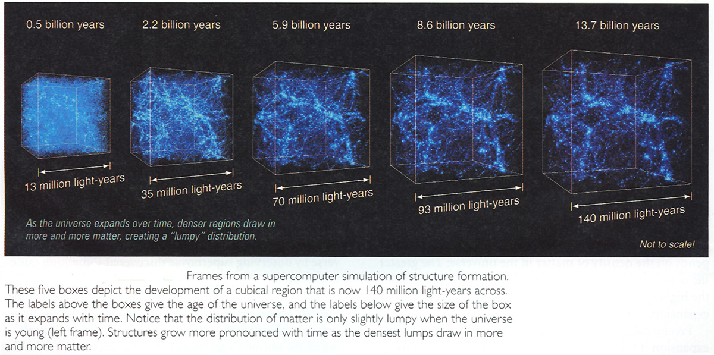

Chapters 26 and 27.
COSMOLOGY AND THE EARLY UNIVERSE

[Note: these notes and the lectures cover chapters 26 and 27 together, with topics discussed in a somewhat different order than in the textbook. References to textbook sections and pages and figures are given below. These notes will be of most benefit if you have already read chapters 26 and 27. This material is probably the most difficult, and also the most interesting, of the entire course, so you will have to read very carefully. Because of the amount and difficulty of the material, I will not test you on the “Discovery” or “More Precisely” sections of your text, but I suggest that you read them anyway.]
The diagram below illustrates what we will be interested in from an observational point of view—we want to see the universe in the distant past by looking far away. At first we only want to observe more and more distant galaxies (to get the “Hubble constant”), count up all the matter we can see (and can’t) see in order to find what kind of space-time we live in, but we end by probing times when the universe was only 100,000 yr old (the cosmic background radiation), and even a few minutes old (the formation of deuterium and helium, whose abundance can’t be explained by formation in stars). Then (ch. 27) we try to go back to extremely small times, finding that the spacetime of the universe probably underwent a fantastic but theoretically sound “inflation” when it was only a tiny fraction of a second old. Finally, as we try to understand the stages of the universe that are inaccessible to present-day physics (quantum-gravity), we will enounter strong suggestions that a viable theory may be one in which the universe has many more dimensions than three, and even more speculative things.

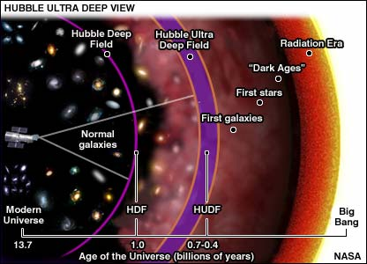

The Big Bang
Hubble’s law: velocity = H₀ x distance ⇒ expanding universe.

Now can ask: How big? When did it begin? How will it end? These are questions of cosmology, questions about the universe as a whole. Although there have been other contenders over the years (the “cold big bang” and the “steady state cosmology”) we’ll see that only the “hot” big bang theory (and only a particular form of it: inflationary dark matter big bang) accounts for the observations, and does so very convincingly, but at the expense of introducing two entities whose nature is completely unknown: dark matter (already known) and dark energy.

How long since all galaxies (and everything else) were in the same place?
Time = distance/velocity = d/(H₀ x d) = 1/H₀ ~ 15 billion years
This is when the “big bang” must have occurred; i.e. it is the age of the universe. (Actually the age is a little different than the above estimate because the universe hasn’t been expanding at constant speed.) Note that this age is consistent with the age of the oldest objects whose age we can determine in our Galaxy, the globular clusters.
Olbers’ paradox: why is the night sky dark instead of as bright as the surface of a star? (Think of forest analogy discussed in class. Also see Fig. 26.3.) Either universe is finite in extent, or it evolves in time, or both. (Think: why?)
The finite age of the big bang resolves the paradox because we can’t see anything more than 15 billion light years away.
See Fig. 26.4 to be convinced that every observer in the universe would see the same Hubble flow. Also see “coins on a balloon” drawing, Fig. 26.5, or raisins in rising (expanding) raisin bread. Notice that this “explosion” involved the whole universe, all of space. It happened everywhere at once.
Correct interpretation of the galaxy redshifts: It’s not that galaxies are moving away from each other, but that space is expanding. This “stretches” the wavelengths of all the light emitted. Light from distant objects was emitted long ago, and so has been stretched (redshifted) more. (See Fig. 26.6)

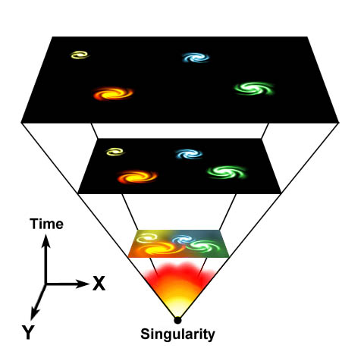

Note: Galaxies, planets, any objects that are held together by internal forces, are not expanding. So, for example, you are not getting larger as the universe expands. Only the systems that are unbound like galaxy clustering on large scales (>> 1 Mpc) are expanding, with individual objects (galaxies) moving away from each other.

What came “before” the Big Bang? We will only be able to try to trace the history of the universe back to when it was 10⁻⁴³ seconds old (!) Known physics breaks down at earlier times (need quantum gravity theory—same problem we encountered in asking what it’s “really” like inside a black hole).
To come up with a theory for the universe as a whole, theorists need to assume the cosmological principle (p.695):
1. Homogeneity—local universe looks about the same no matter where you are in it. This is same as saying: no structure on size scales larger than a small fraction of size of observable universe.
Largest known structures ~ 200-300 Mpc (“Sloan Great Wall”—see Fig. 26.1; pencil beam survey in Fig. 26.2). This is much less than size of observable universe (~ 5000 Mpc). [Note: Universe could be much larger, or even infinite—we just can’t see back any further in time or space.] So homogeneity probably OK.
2. Isotropy—no preferred direction. Universe looks the same in all directions. OK.
Cosmological principle implies universe has no edge and no center (ultimate principle of mediocrity).
[Note: I strongly recommend that after you read the text Chaps.26 and
27, you wander through the Wikipedia free encyclopedia at http://en.wikipedia.org/wiki/Physical_cosmology]
Fate of the universe (sec. 26.3, 26.4, 26.5)
“open” ⇒ not much gravity, expands forever
“closed” ⇒ gravity strong enough to reverse the expansion
(See Figs. 26.8-26.10)
Which? Depends on the whether the average (i.e. smeared out) density of the universe (which determines how much gravity is capable of slowing down the expansion) is > or < critical density (whose value you don’t have to memorize).
The ratio of the actual mean density of the universe (which we will try to estimate) to the critical mean density is given a special name, “omega nought” Ω₀.
Ω₀ < 1 ⇒ open universe; Ω₀ > 1 ⇒ closed universe
Evidence:
1. Add up all the luminous matter in galaxies. Get Ω ~ 0.01. The x-ray gas observed in clusters of galaxies gives another ~ 0.01. So together the luminous matter only gives ~ 1/50 critical density.
2. Dark matter inferred from galaxy rotation curves and the motions of galaxies in clusters gives Ω ~ 0.2-0.3.
3. Abundance of deuterium ²D (see pp. 727-728). Produced in the big bang when the age of universe was only a few minutes (²D is destroyed in stars) and the temperature of the universe was passing through about a billion degrees.
p + n → ²D + energy; ²D + p → ³He; ³He + n → ⁴He.
Denser universe now ⇒ denser universe then ⇒ less ²D (because it reacts all the way to ³He). See Fig. 27.6. The observed deuterium abundance is large ⇒ Ω = 0.03 ⇒ tells us only about the baryonic matter (protons, neutrons, electrons, i.e. “ordinary” matter). Notice two important things from this:
a. This baryonic Ω is consistent with the Ω we got from adding up all the luminous material in 1. above.
b. This implies that the dark matter cannot be baryonic: rules out brown dwarfs, white dwarfs, black holes, rocks,… ⇒ this is one of the main reasons for thinking that dark matter must be nonbaryonic exotic subatomic particles.
So Ω₀ ~ 0.3 ⇒ open universe, should expand forever.
Actually it now appears that the universe is not really “open”, and is not even slowing down its expansion; instead it is accelerating its expansion—see pp. 706-709). This is a recent discovery, and implies the existence of a new form of energy (not matter) that is usually referred to as “dark energy” (sec. 26.6).
The illustration on the next page should help you visualize these possibilities.

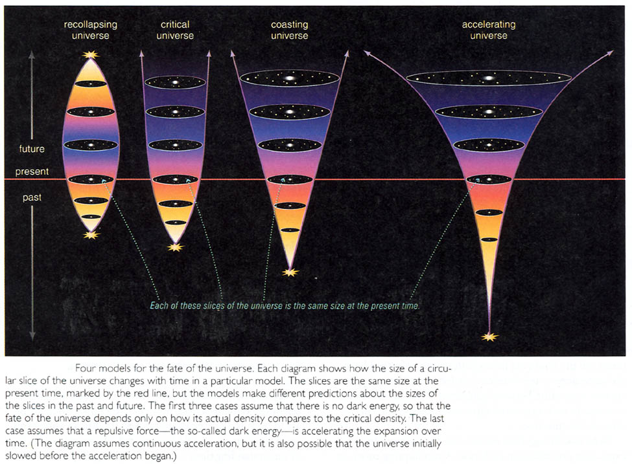

[What is fate of open universe? (Not on exam, but too interesting to pass up.) By ~10²⁵ yr., all gas and stars would be in the form of remnants—brown dwarfs, white dwarfs, neutron stars, black holes. Grand unified theories (GUTs) of particle physics predict proton decay in ~ 10³⁰ yr. ⇒ all these remnants (except black holes) will be converted to electrons and neutrinos. Black holes unaffected by proton decay, but get “quantum evaporation” of star-mass BHs in ~ 10⁶⁶ yr. Eventually even supermassive BHs in the centers of galaxies would evaporate. Even if no proton decay (theory still uncertain enough), neutron stars can still “quantum tunnel” to become black holes! Time required in years is 1,… #zeros > # particles in the universe! But it would eventually happen! The universe would eventually be photons, electrons, and positrons. Eventually “radiation drag” brings electrons and positrons together for annihilation, so the entire universe would consist only of photons, losing energy forever by the redshift due to the expansion of the universe. All of this and more is covered in a recent popular-level book by F. Adams and G. Laughlin (and their more technical version—in Reviews of Modern Physics).]
What we want to understand next is why a value of Ω₀ that isn’t almost precisely 1.000… would be disastrous for our theories (involving something called “inflation”—see below). And, amazingly, recent evidence (especially from the cosmic background radiation—see below) is convincingly consistent with Ω₀ = 1.0 and other evidence (from mapping the most distant parts of the universe) indicates that there exists a completely new form of energy called “dark energy” (or “quintessence” or “phantom field” that can account for this “extra” Ω, so that
Ω (baryonic matter) + Ω (dark matter) + Ω (dark energy)
= 0.03 + 0.3 + 0.7 = 1.
In what follows, it will help if you have an overall picture in your mind of the timeline of the big bang universe.
Starting from time zero, just remember that as the universe expanded, it cooled, and this cooling is responsible for most of what happened. Also note that the universe must have originally just been composed of fundamental particles (quarks, photons, neutrinos, dark matter whatever it is… no atoms yet!). During the expansion and cooling we went through the GUT era, then (we hope) inflation (these first two both at extremely early times), then nucleosynthesis at about a few minutes after time zero (when helium and deuterium got formed), then decoupling and the formation of the cosmic background radiation at about a million years after time zero, the amplification of the “ripples” in the universe into the “cosmic web” large scale structure of galaxies and their clusters that we see today at about 100 million years after time zero. I’ll illustrate on board in class. You don’t have to know the epochs in as much detail as given in Table 27.1, p. 721, of the textbook.

Before going further, we need to understand two basic predictions of the big bang model:
1. The helium abundance. (See pp. 726-727) The amount of ⁴He that was produced when the universe was a few minutes old and the temperature was about a billion years is predicted to be about 8 percent by number, or 25 percent by mass, almost independent of any other assumptions about the nature of the big bang. But since helium is only destroyed in stars, there should be no stars with He abundances larger than this. In fact, the He abundances of the oldest stars we can see comes out to all be about 25 percent by mass! This is the 2nd major success of the big bang theory (although it is played down in the textbook). (The first was “just” accounting for the Hubble expansion.) Your textbook apparently forgot to point this out.
2. The cosmic background radiation. (pp. 711-712, then more recent results on pp. 735-738).
All theoretical calculations of the expansion of the universe predict that when the universe had expanded and cooled for about 300,000 yr, the protons and electrons were finally moving slowly enough (because the temperature had dropped to only about 4500K) that they could combine into atoms. But before this time all the radiation in the universe was being scattered by the free electrons; after this time there were no more free electrons, and so the radiation never interacted again (hence this is called the epoch of decoupling—see p. 728)—it just expanded and redshifted with the rest of the universe, until today it is predicted to have a temperature of about 3 degrees above absolute zero and be a nearly perfect blackbody (because it was scattered around so many times before it was “released”). This temperature corresponds to radiation whose peak emission is in the radio (actually microwave) part of the spectrum. This prediction was made in the 1950s but the predicted radiation could not be detected because radio telescopes were not sensitive enough.
1965: This radiation was accidentally discovered (discussion in class). Since then its temperature has been confirmed to be about 3 degrees (2.728 K) and its spectrum has been measured (mainly by the COBE=cosmic background explorer satellite in 1989) to deviate from a blackbody by less than 0.005%. We call it the “cosmic background radiation” or CBR.
This is the 3rd (and maybe most remarkable) success of the big bang theory. Later we’ll see that more detailed observations of the CBR have already yielded much more information about the nature of the origin of the universe and its nature, and give even stronger support for the big bang model of the evolution of the universe. (pp. 735-738 of text)
Now let’s get back to two very serious problems.
1. The fact that the observed Ω₀ was probably ~ 0.2 to 0.3 (mostly dark matter) but not vastly different from 1.0 gives “the flatness problem.” (p. 729 of text; today we think Ω₀ is even closer to 1.0) Every calculation of the big bang shows that if Ω₀ is anywhere near unity now, then it must have been extremely close to unity in the past. E.g. at age ~ a few minutes (time of nucleosynthesis), Ω₀ would be unity to within 1 part in 10¹⁵! Why should this be??? No one understood this until the idea of inflation was suggested.
Because Ω₀ determines whether spacetime is curved positively (closed) or negatively (open), the case Ω₀ = 1 is called “flat” spacetime; that is why this is the “flatness problem:” Why is spacetime almost exactly “flat?”
The currently favored solution: cosmic inflation. (Most of sec. 27.4 is a discussion of this—it is a good explanation so be sure to read it.) When universe was ~ 10⁻³⁵ seconds old (T~10²⁸ K!), the strong nuclear force separated from the other forces. This caused a phase transition of spacetime (like water freezing when T drops) to a state that was unstable and high-energy ⇒ “false vacuum”. The universe remained “unified” a little too long, and during this time the vacuum acquired a huge pressure that accelerated the expansion at an enormous rate.
Within ~10⁻³² sec, the universe expanded by a factor of ~ 10⁵⁰! (See Fig. 27.11). Then resumed “normal” expansion. So any initial curvature of space is virtually erased by the rapid inflation (see Fig. 27.13), which “stretches” out spacetime enormously. So inflation predicts that Ω₀ must be almost exactly 1.
2. The “horizon problem”: How could distant parts of the universe look similar to each other (in an average sense—recall that the universe looks “homogeneous” on large scales) when they didn’t have time to be in causal contact when the universe was younger and smaller? (through light travel time) i.e. they are beyond each other’s horizon (how far away you can see something given age of universe; e.g. when universe was 3 years old, horizon was only 3 light years). See Fig. 27.8 in text.
The following illustration may help clarify the horizon problem.
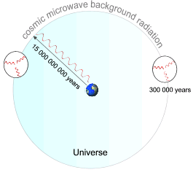
Inflation also solves the horizon problem (because points initially very near each other are rapidly expanded to be very distant, so everything was in causal contact at these very early times before inflation). See Fig. 27.12.
→But recall that Ω₀ due to the observed + dark matter only gives about 0.3, not 1.0 (flat spacetime) as required by inflationary cosmology. Cosmologists were frantic, since if this were true, inflation couldn’t be supported, and we’d be back to the flatness and horizon problems again.
1998: Supernova standard candles used to get distances and redshifts of most distant objects yet. Result: The most distant galaxies are moving away from us much slower than expected in any model, meaning that the universe in the distant past was expanding at a smaller rate, not a rate equal or greater than the present rate. The universe is not slowing down, but speeding up! Some kind of “antigravity” entity is apparently required ⇒ “dark energy” (or “quintessence” or “phantom energy” or … Some refer to it as the cosmological constant, after Einstein who introduced it just because he couldn’t believe the universe was expanding at all)
The amount of Ω₀ that is required to account for this weird acceleration of the universe comes out to be about 0.7. 0.7 + 0.3 = 1 ⇒ inflation theory survives. But the “expense” is that we now know that the universe is even weirder than we thought: no one has any idea of what “dark energy” is.
Could something be off? Maybe the supernovae are not as good standard candles as thought, e.g. maybe they are not the same peak luminosity very far away (when the universe was young).

Another independent test of dark matter and dark energy: The cosmic background radiation.
The CBR provides another test of the inflationary cold dark matter cosmology. It has to do with the question: where did galaxies (and clusters of galaxies, and all the structure we see) come from? Everyone believed that the formation of this structure is due to the amplification (by gravity) of initial “seed” fluctuations (“ripples” in the density field when the universe was very young). [Sec. 27.5]
Without dark matter, the initial fluctuations could have produced structure, but then predict relatively large corresponding fluctuations imprinted on the CBR (because the radiation was tied to the matter).
But with dark matter (if non-baryonic), most of the matter does NOT couple to the radiation, so you could have fluctuations in the dark matter density that only produce very small CBR fluctuations (~ 1 part in 100,000).
COBE satellite 1992: spatial fluctuations detected at about this level. (Fig. 27.16—a famous illustration, because astronomers had been waiting for this detection for decades.)
In fact calculations showed that if Ω₀ = 1, the spatial distribution of the fluctuations should mostly be about 1 degree large in the sky. Other values of Ω₀ predict different sizes. 1999: MAT (Microwave Anisotropy Probe) satellite and BOOMERANG (balloon-born observation) establish that peak power does occur at almost exactly 1 degree size!
More recent and accurate observations by the WMAP spacecraft confirm this (Fig. 27.17). This is a direct measurement of Ω₀ and shows that the universe does appear to be flat, just as required if inflationary cosmology is correct. But even more:
The theory also predicts a second peak, and further peaks, in the distribution of sizes of CBR fluctuations at smaller scales, which have now been detected! This is illustrated in Fig. 27.18. These peaks are due to the fact that the fluctuations in the early universe caused sound waves to propagate through the gas, and these left an imprint on the radiation: So the CBR is actually a way to “see” the imprint of the fluctuations from which all the structure in the universe originates. →Currently, the only model that accounts for all these peaks correctly requires cold dark matter (~ 30%) + dark energy (~70%), just as we found from other “observations” of dark matter (rotation curves, clusters of galaxies, etc.) and dark energy inferred from distant supernovae.
Future: Planck (European satellite) planned for 2007 (?), will give even more precise measurements of CBR.

The next two images of the WMAP CBR fluctuations may show you (by eye) that there are several dominant scales. Your textbook has an even larger zoom.
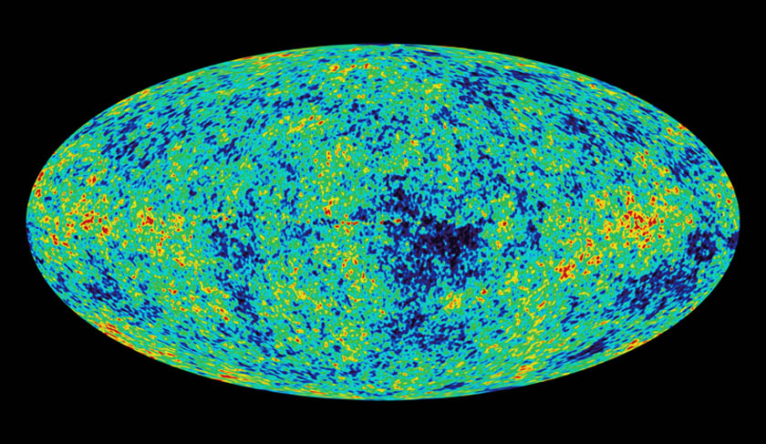

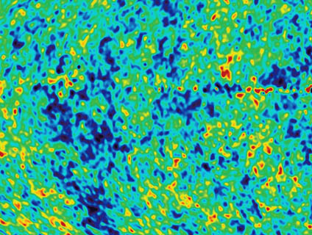

This is considered to be an astounding success of the theory of inflationary cold dark matter cosmology. And the WMAP results showing the secondary peaks at different sizes are interpreted as demonstrating again that the universe is mostly “dark energy.”
Further evidence: Huge galaxy redshift surveys are now obtaining redshifts for hundreds of thousands of galaxies, and the motions give a more precise value for the amount of Ω₀ contributed by matter (i.e. gravitation visible and dark matter) at the scale of the whole universe: 0.3.
So once again we see that with the “dark energy” acceleration of the universe giving another 0.7, the total adds up to 1.0, consistent the idea that the universe underwent inflation. This is extremely important, because inflation is just about the only way around the flatness and horizon problems! So cosmologists tend to say that we now have a consistent cosmological model that explains all observations—the clinker is that all evidence supports that the universe is 30% dark matter and 70% dark energy.
But we really have no idea what this “dark energy” (sometimes called “quintessence”) is!

What caused these initial fluctuations in the matter?
A perfect vacuum (no matter or energy) should give rise to virtual particle-antiparticle pairs, leading to natural quantum fluctuations ⇒ universe appeared from nothing! These would occur in the GUT era, as a “self-creating universe.” These quantum fluctuations would be tiny, but then inflation would cause them to grow to large size (see how handy inflation is?); they eventually become the structure we see today!
The illustration below is a computer simulation of how random fluctuations in the early universe would be organized by gravity and expansion into structure that is very similar to what we observed in the universe today—actually this model only works out so well because it contains cold dark matter. A model with no dark matter would not show the degree of clustering or more detailed properties.

More recent theoretical suggestions and developments: (not on exam)
1. More inflation models. For example “chaotic inflation” (different inflation rates in different parts of the universe). Only those regions which inflate more than some amount can live long enough for life to evolve, or even for galaxies to form. So there may be many other inflated regions (even an infinite number if the universe is infinite) which lie beyond our horizon. This is often referred to as a “multiverse.”
2. Cosmic strings—defects in space time due to the inflationary phase transition; something like cracks in ice cubes when water freezes. The “dark energy” could be a tangled network of very light cosmic strings or walls, which are still allowed by current observations of CBR (but most people think this idea is on the verge of being disproved).
3. Superstring theory (or more recently M theory)—the current best candidate for a theory of quantum gravity. Predicts that the universe must be 10-dimensional, but that 7 of these dimensions have “collapsed”. In these theories “particles” (like quarks, or neutrinos) are the “modes” of these 10-dimensional “strings.” So these theories could in principle account for the masses of the fundamental particles.
4. Related to 3 are the concepts of “brane world” (our universe is just one “membrane”-like structure moving around in a 4-dimensional hyperspace; big bang corresponds to interaction of two branes??) and “mirror (parallel) universes that coexist with the one we experience.
5. Even stranger suggestions…

