Stellar Explosions (ch. 21)

First, a review of low-mass stellar evolution by means of an illustration I showed in class. You should be able to talk your way through this diagram and it should take at least half an hour.
Remember that all stars less massive than about 8 Mo go through these phases (except not the helium flash above about 2 Mo). What is the major reason why the advanced evolution of higher-mass stars is so different?

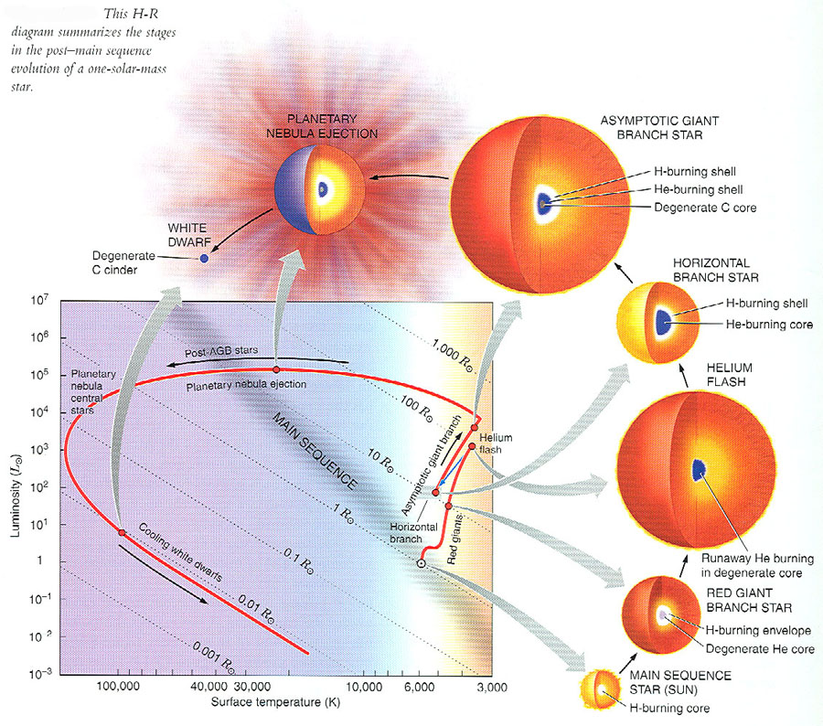

↑ Before discussing high-mass stellar deaths, don’t forget the material in Sec. 21.1: “nova explosions” by mass transfer from a RG to a WD companion. This is really a continuation of sec. 20.6 on binary star evolution. Read this on your own and I will only discuss very briefly in class.
You will find it extremely useful throughout the rest of the course to understand the idea of an accretion disk that is introduced in this section. They will come up again and again.

Death of a High-Mass Star
In short: Envelope explodes as a core collapse supernova. The core implodes and ends up as a neutron star or (more massive) a black hole. Let’s see how this occurs. (Remember, this is all theoretical calculations, but later you’ll see that there is surprising observational confirmation for these calculations.)

Core is layered like an onion, with heavier elements closer to center (since they are the ashes of a previous fuel):

He, C, O, Ne, Mg, Si, Fe

These are the main elements produced up to this phase because they are produced by adding helium (He, “alpha particles”) to heavier and heavier nuclei. (Iron Fe is in bold in this list because it is the “end of the line” for stellar nuclear fusion—see below.)

(Question to see if you understand nuclear fusion: why is so much easier to burn He with, say, O, rather than C+O or O+O ? Hint: why do main sequence stars burn hydrogen rather than something heavier?)

On the next page is a cutaway drawing of what the inside of a massive star might look like as it completes more and more burning stages:

First way to get a supernova: core collapse.
Massive stars burn nuclear fuels up to iron (Fe). But nuclear fusion of iron does not produce energy, it uses energy. This leads to loss of pressure support ⇒ core collapse
Temp. is so large (~10 billion K) that the gamma ray photons (Wien’s law) have huge energies and photodisintegrate the iron into protons and neutrons. This absorbs even more thermal (heat) energy, so the core collapses even faster! Gravity is having its way…
The protons combine with electrons to give neutrons and neutrinos (which escape immediately—later we’ll see that they have been accidentally observed in one case). The core has been converted into one massive collection of neutrons, all collapsing under gravity.

Now nothing can stop the core collapse except neutron degeneracy pressure, which sets in at a density of about 10¹² grams per cc (!). Analogous to electron degeneracy pressure (which saved lower mass star cores as white dwarfs), but at much higher densities.
But the collapse is so violent that the core overshoots this density and then “bounces”⇒ violent shock wave propagating outward.
All this takes ~ 1 second. (Remember, star took at least millions of years to get to this phase in its evolution.)
The shock wave blasts through all the overlying layers ⇒ star explodes as core collapse supernova.
(We’ll see another way to make a supernova below.)
The next two pages show a simulation of the explosion deep in the core, and an illustration showing the chain of events that leads to this spectacular death for massive stars.

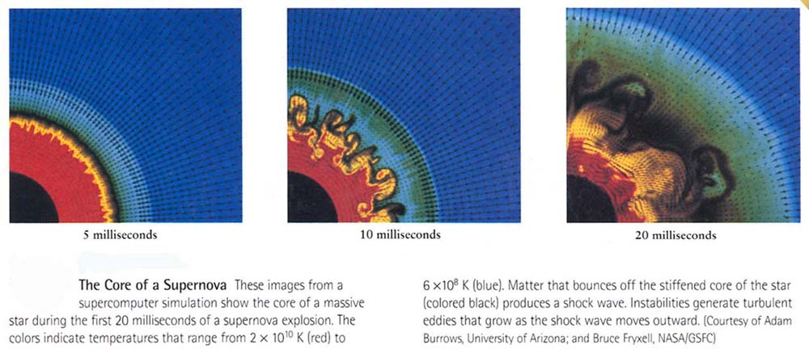

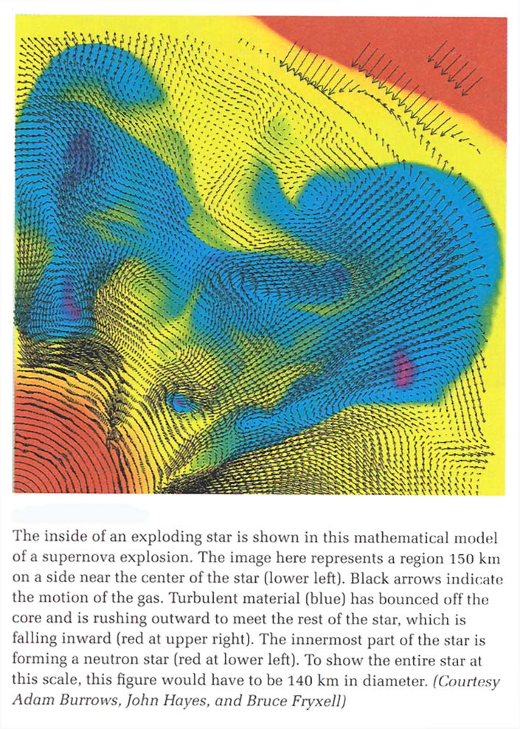

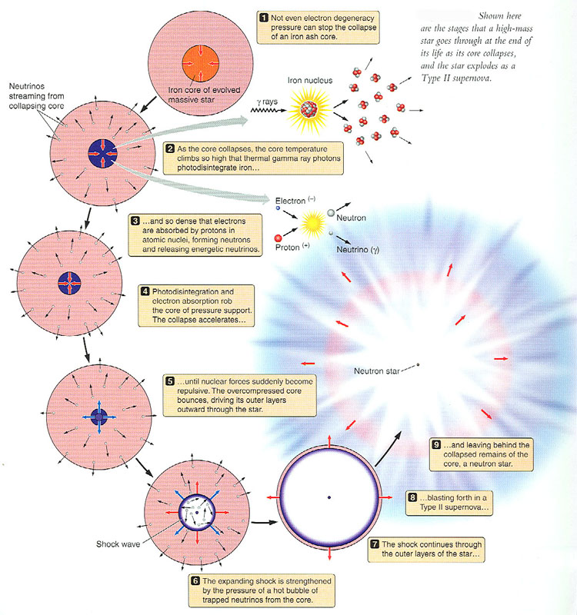

Many supernovae (SN) have been observed in historical times in our own Galaxy, visible to the naked eye (sometimes in daylight!). Best example is SN 1054 A.D., the Crab Nebula. (Text has great images of what the remains of the explosion look like today, nearly 1000 years later.)
A SN produces a billion solar luminosities in just a few hours or less. Until discovery of gamma ray bursts (ch.22), these were, gram for gram, the most luminous objects in the universe. That is why they can be observed even in very distant galaxies (e.g. 100s of Mpc away), or even at the edge of the observable universe (later we’ll see that they play a crucial role as the standard candles that have led to the belief that there is a “dark energy” that pervades the universe).

A second way to get a supernova :
A white dwarf accreting matter from a binary companion.
This increases the mass of the white dwarf. If white dwarf mass gets larger than 1.4 Mo (the “Chandrasekhar limit”), electron degeneracy pressure can’t support the white dwarf against gravity and the white dwarf collapses. As it collapses, it heats up, carbon fusion occurs explosively ⇒ carbon detonation supernova.

Observationally, there are two classes of supernovae, which differ in their composition and their light curves (brightness vs. time).
Type I: H-poor ⇒ carbon detonation SN

Type II: H-rich ⇒ core collapse SN
(You don’t have to memorize the types, just that there are two of them and how they differ.)
See Fig. 21.9 for good illustration of the two mechanisms.

The SN explosion produces a fast-moving expanding shell of gas, observed as supernova remnants (SNRs). E.g. Crab Nebula (explosion in 1054 A.D. recorded by Chinese and Native Americans). Hundreds of these are known (see illustrations in book for the interesting forms that are produced).
How can you prove that the SNR is from the 1054 A.D. SN? Observed radial velocities of a few thousand km/sec gives age, which comes out to be about 950 years as it should. See Discovery 21-2 on p. 554.
From the observed number of SNe (supernovae) in our own and other galaxies, we expect about 1 SN per 100 years in our Galaxy. But the last one was seen 400 years ago (Tycho’s SN). So we are overdue!
Here is an image of the Cas A SNR in X-rays (left) and at radio wavelengths (right). The X-rays are emitted because the gas is so hot (~ million degrees K), while the radio emission is from electrons that are gyrating at nearly the speed of light around the strong magnetic field in the remnant—this is where it is believed that cosmic rays are accelerated.

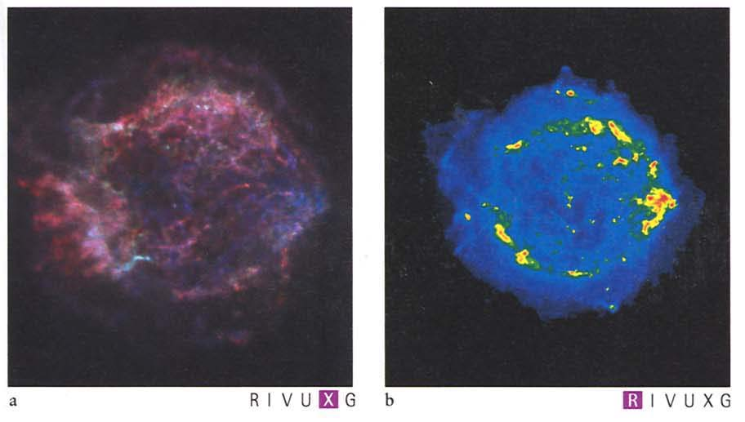

SN 1987A in the Large Magellanic Cloud (LMC)
(Fig. 21.7 and Discovery 21-1 on p. 550)
This was a major event for astronomers, since by far it’s the nearest SN since we’ve been observing them. It outshined the entire LMC galaxy at its peak!
(See illustration below)

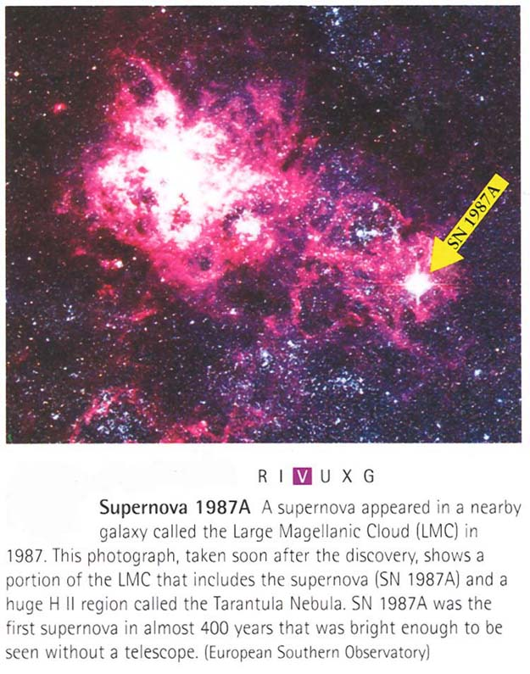

SN 1987a gives fiarly good confirmation of the core collapse model for Type II SN.
In particular, an unexpected neutrino burst was observed about 20 hours before the explosion was observed (visually) by underground neutrino detectors in Japan and U.S. (The delay is because most of the light from the SN has to diffuse through the thick exploding envelope, while the neutrinos pass right through.)
But the progenitor object (pre-SN) was a blue supergiant, not red as expected, and the light curve was strange, so it is something of an anomaly.

SN as distance indicators. If all SN reached the same peak luminosity in their light curve, then we could use them as standard candles to get the distances by observing supernova light curves, since we know the luminosities of nearby supernovae in galaxies whose distances we know by other means.

Actually one subclass of supernovae are found to have remarkably similar peak luminosities. Later we’ll see how these have been used to map the expansion of the most distant parts of the universe, and to discover that most of the universe is apparently filled mostly with the most mysterious thing in astronomy: "dark energy."

Formation of the elements

This is an especially important subject. Where do all the (110 or so known) different elements, from H, He,…to uranium, lead,… come from?
Except for H and He, they come from stellar nucleosynthesis: nuclear fusion in stars.

Look at the pattern of abundances of elements as a function of their atomic weight in Fig. 21.13 (p. 556). You can see that the heavier elements are less abundant than the light elements, and that there are peaks at (C, N, O) and at Fe.
Most heavier elements up to iron are made by helium capture, which we discussed earlier. Get C → O → Ne → Mg → … → Fe.
Their masses are divisible by four (do you understand why?)

Proton capture—makes the (lower abundance) elements whose mass is not divisible by four. These are the “dips” between the minor “peaks” in the figure.

Neutron capture (mainly on iron). Two types:

1. s (slow) process—takes place in red giant interiors, stops at bismuth 209.

2. r (rapid) process—probably takes place in supernova explosions, goes out to thorium 232, uranium 238, plutonium 242.

Observational evidence for stellar nucleosynthesis:

1. The theoretically-predicted abundances agree with observations (Fig. 21.13), e.g. the peaks at C, O and Fe, and even the patterns in between and the s-process patterns. This is amazing agreement considering that we are not even sure about the details of stellar explosions.

2. Technetium—this element is predicted to be produced in the s-process, but it is radioactive, and decays in 200,000 years. Yet it is observed in the atmospheres of some red giant stars ⇒ must have been produced in the interior and mixed to the surface, where the red giant wind will spew it back into the interstellar medium. This is direct evidence that s-process nucleosynthesis occurs in the cores of stars!

3. Supernova light curves (see Fig. 21.18): For
Type I supernovae, the light curves can be fit by the radioactive decay of nickel 56 (55 days) and cobalt 56 (78 days); these are predicted to be some of the main nuclear products of nucleosynthesis in carbon detonation supernovae. We don’t actually see the nickel and cobalt, but the timescales for decline match very well. And the gamma ray line emitted by cobalt 56 has been observed from a supernova in another galaxy.

Taken together, this is strong evidence that the theory of stellar nucleosynthesis in stars is correct, and also supports the explosion models for supernova explosions.

