Last time: Star Clusters (sec. 19.6)
Make sure you understand the H-R diagrams in Figs. 19.18-19.19 (and see the HR diagrams shown below).

Can you explain what determines the lifetime of a star cluster (not the current age, but how long it will remain as a cluster)?
What is suggested by the fact that all globular clusters are much older than any open cluster?

Below are two important HR diagrams:
1. The evolution of a number of stars all formed at the same time in a cluster. Note that both during the approach to the main sequence and evolution away from the main sequence the most massive stars evolve most rapidly. This is what gives us a way to obtain ages of clusters from the extent of the main sequence.

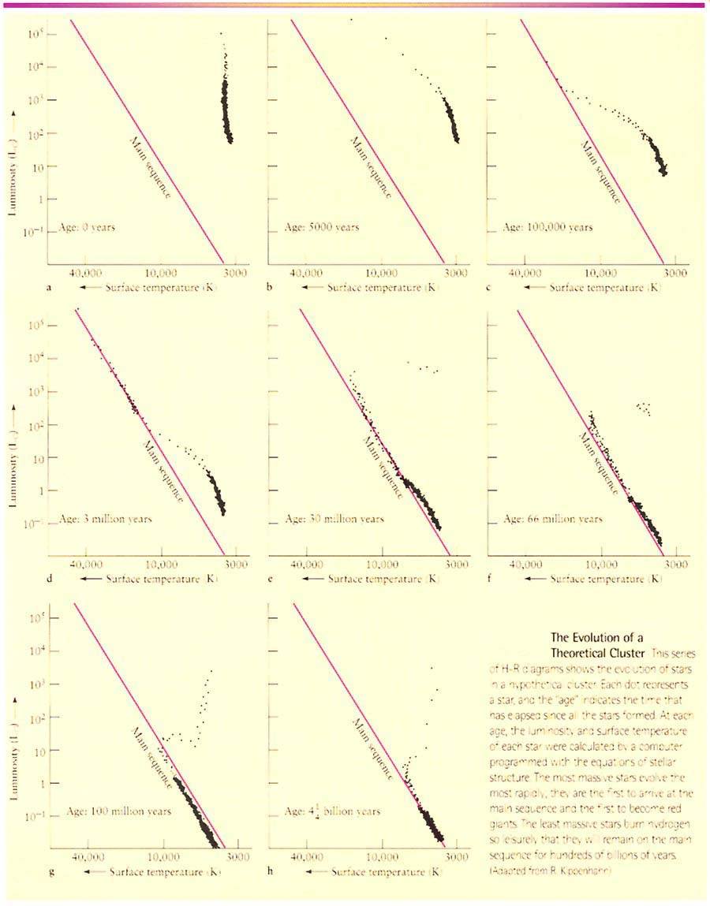
2. This illustration shows some real clusters’ HR diagrams, illustrating directly how ages of clusters can be estimated. The oldest cluster known, M67, is only about 4-5 billion years because almost all clusters dissolve or “evaporate” long before this. M67 is just a “lucky survivor.”

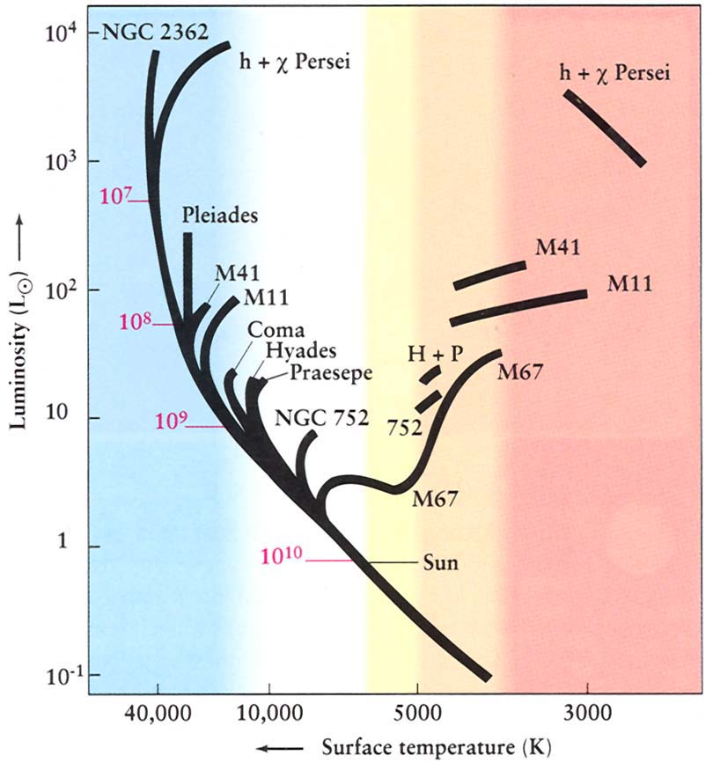

Stellar Evolution (ch.20)

Main Phases for stars ~1Mo to ~8Mo (Notation from here on: Mo means M_{sun} = mass in units of the Sun’s mass)

Main sequence equilibrium: pressure balances gravity at every depth, so hottest in center ⇒ nuclear reactions H → He “core H-burning”.

Two nuclear reaction procceses: proton-proton (dominates in stars ~ sun’s mass and lower), and CNO cycle (dominates in stars more massive than sun; see More Precisely 20-1).

Stable, lasts most of star’s lifetime. (Will explain why this is so stable in lecture.) [You already know how lifetime varies with mass.]

Depletion of H in core [see Fig. 20.2].
Starting in center (hottest), and moving out, the He (the “ashes”) accumulates in core (can’t burn the He as fuel—would require higher temperatures), H-burning only occurs in outer core.

Contraction of He core. He nuclei can’t fuse, so there is a pressure deficit compared to gravity, so core contracts, heating up (just like for a protostar). But the overlying layers heat as well, causing H-burning just outside the core to become very rapid ⇒ H shell-burning. See Fig. 20-3. So star gets brighter (L rises) even though it has lost its fuel at the center.
The layers above the H-burning shell expand (not really understood, although models are undoubtedly correct—explained in class), so surface temperature cools ⇒ subgiant branch, then star ascends the red giant branch. (See Fig. 20-4)
Red giants: surface is large, luminous (partly because of large surface area), cool, but the core has shrunk to ~ 1/1000 size of entire star (~ size of earth). The density in core is huge, around 10,000 x MS central density (~ 10⁶ gm/cm³ vs. 10² for MS phase). This core will later become a white dwarf when exposed by the loss of the envelope.

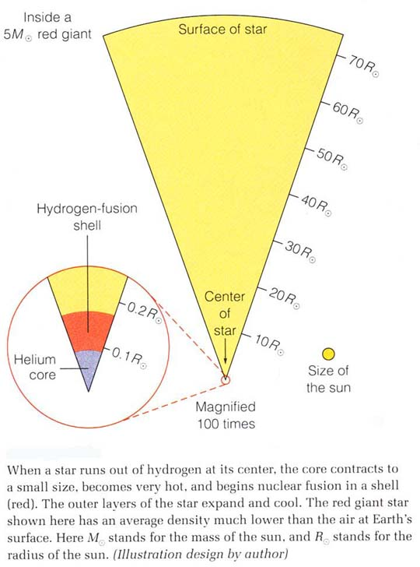

Helium nuclear fusion. Occurs by triple alpha process whereby three He-4 nuclei combine in a two-step process to form carbon-12 plus some energy. [The lucky placement of a “resonance” without which there would be no carbon or anything heavier is discussed in class.] This reaction requires T~100 million degrees K, which the core has attained by its contraction and heating. But for low mass stars (less than about 2 Mo), when the He gets hot enough to ignite, the core is so dense that the gas is degenerate. (Recall discussion of brown dwarfs—same effect).

Electron degeneracy pressure—due to quantum effect called “Pauli exclusion principle.” Result is that pressure does NOT depend on T, so He ignition increases T, which increases reaction rate, which increases T, … ⇒ runaway “helium core flash” (see p. 521): energy gets soaked up by the huge “buffer” of the envelope, so virtually unobservable from the outside—but very well established theoretically—note how almost all of this is stellar evolution theory).
Eventually (after only a few hours or less), the huge energy input does cause the pressure to increase and the core expands, making itself non-degenerate; it settles into a new equilibrium between pressure and gravity converting He into C ⇒ called “horizontal branch” phase, or just “core He burning.” In effect, the star is given a new chance to resist gravity but for a shorter time than when it used H (He isn’t as efficient a fuel).

Depletion of He in core. He ⇒ C ashes. T too cool to burn C (requires 600 million degrees K!), so core contracts (like after H depletion), heats, ignites He-burning shell. So in this phase have double shell burning (H and He—se Fig. 20.7). Actually get repeating “shell flashes” (again, all theoretical). The outer layers expand continuously during He shell burning, just as for the 1st red giant phase, so the star becomes even bigger and more luminous.
This 2nd ascent of the red giant branch ⇒ “asymptotic giant branch (AGB)”. Now the carbon (He ashes) core becomes degenerate before C can ignite (if original mass of star is less than about 8 Mo), and the temperature stops increasing ⇒ no more nuclear burning possible. (Remember this is only for low-mass stars.)

The HR diagram below shows theoretical evolutionary tracks for low-mass stars of different masses, from 1 to 9 Mo. (9Mo is already just outside of our adopted range for “low-mass” stars.)

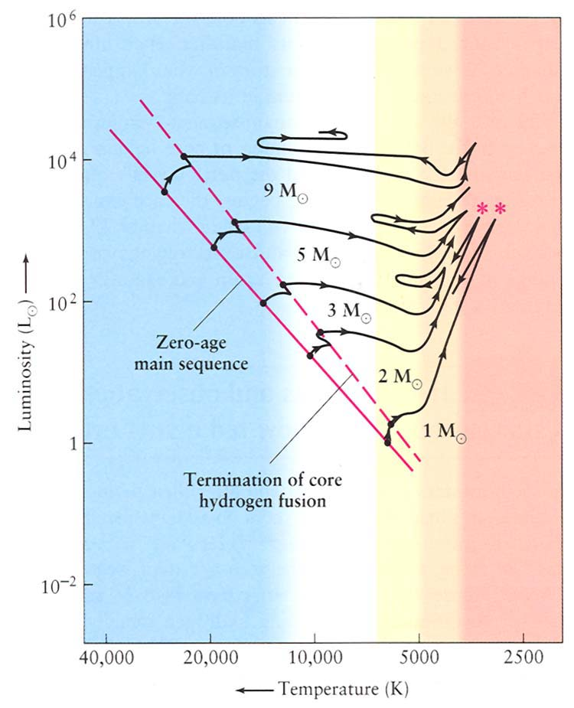
Further evolution of low-mass stars: Planetary nebulae, white dwarfs
During the entire RG and AGB phases, significant mass loss is occurring (observed) by a wind. (Probably the radiation pressure and shock waves from pulsations driving matter away—see Fig. 20.9 and Discovery 20-2.) The star is also pulsating (period ~years). Eventually so much of the envelope is lost that the last bit of envelope gets ejected as a more or less spherical shell of gas called a planetary nebula. (see pretty images, pp. 526-527) (Note: “planetary” has nothing to do with planets; just a historical term.)
What remains, the degenerate hot core, now unveiled, is a young white dwarf, which will just cool and fade forever (unless it receives some new mass from a binary companion…) Since these objects just contain the products of helium-burning, white dwarfs should be composed mainly of carbon (and some oxygen, depending on how far He-burning proceeded).
This is what happens to all low mass stars, by which we mean initial total masses less than about 8Mo.
Shown below is an illustration to help remember the phases of evolution and the internal structure of a low-mass star (like the sun).

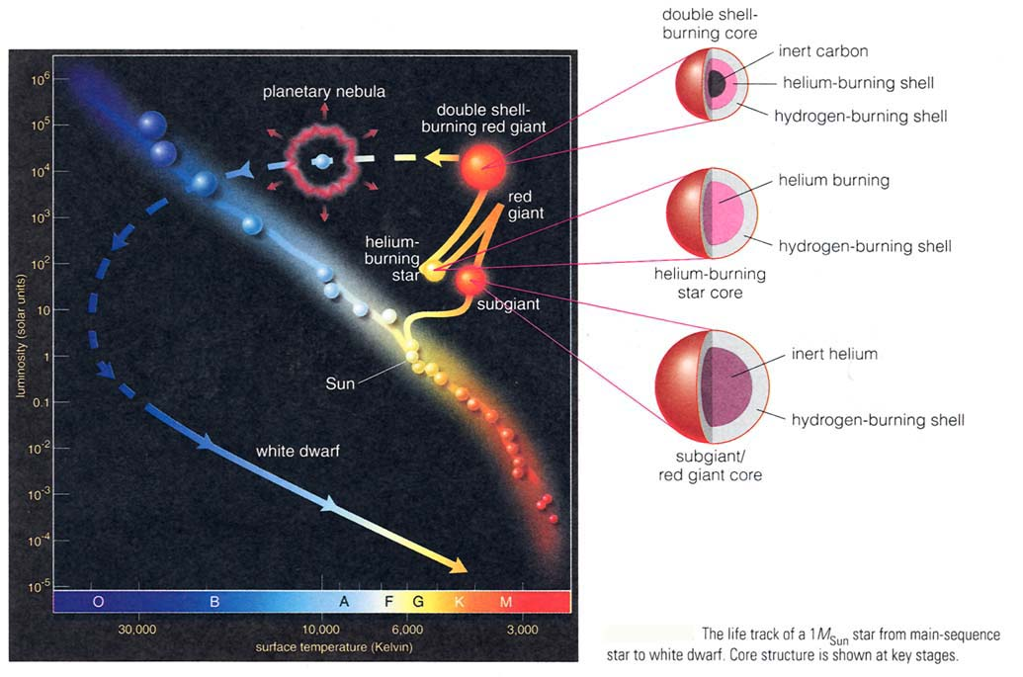
The following HR diagram shows theoretical evolutionary tracks and points representing observed stars, showing how the theory described so far can account for the observations.

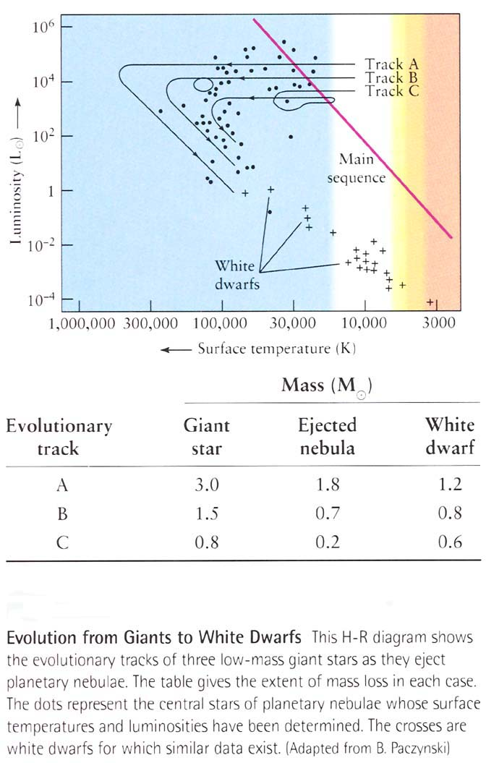

Evolution of high-mass stars
Evolution is similar to low-mass stars, except:

1. They evolve more rapidly through all phases (because they have huge luminosities to support, and are hotter in their cores).

2. Their central densities are lower, so never get degenerate. This means they can keep burning the ashes as new fuels:
H → He → C → O → Ne → …
The star will have an “onion skin” interior, with the heavier “ashes” closer to the center. During this burning the stars cross the H-R diagram horizontally, sometimes with loops (see Fig. 20.16).
Another illustration of this structure is shown below.
\

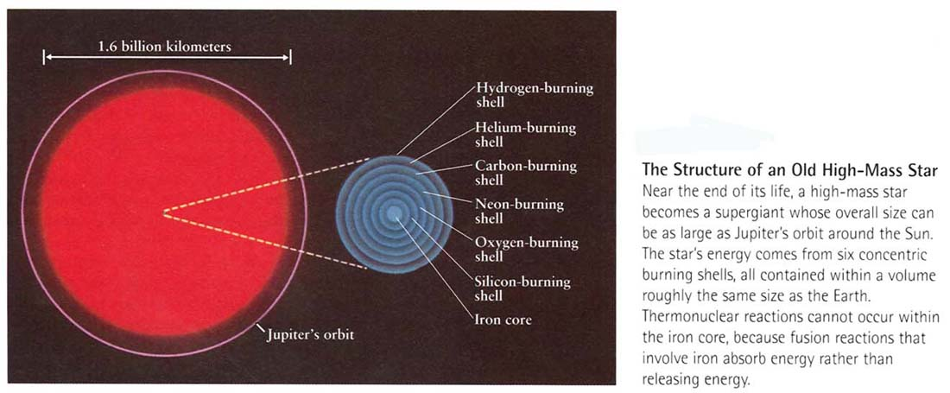

High-mass stars do lose mass, and if they lose enough, their mass at the time the carbon core forms could be small enough to result in a white dwarf. But it is believed that most stars more massive than 8-10 Mo cannot be “saved” as white dwarfs, and instead find themselves with a very different fate… (supernovae, neutron stars, black holes). This is covered in detail in subsequent chapters.

Observing Stellar Evolution in Star Clusters (sec. 20.5)
An intro. to this is sec. 19.6 which you should read again now. Read sec. 20.5 carefully and understand the H-R diagrams of open and globular clusters and their significance. We covered this in class in connection with sec. 19.6.
Extremely important question for you to think about: Why do open cluster HR diagrams have a variety of turnoff masses, while globular clusters all have a turnoff mass around 1 Mo? How is this related to the low metal abundances in globular clusters? The answer to this is the first hint for how our Galaxy formed. [Already discussed in class.]

