The Interstellar Medium (ch. 18)

The interstellar medium (ISM) is all the gas (and about 1% dust) that fills our Galaxy and others. It is the raw material from which stars form, and into which stars eject material when they die, so it is important to understand its properties. Also, remember that these dust grains are what are supposed to collide and grow into terrestrial-like planets!

The ISM is distributed in a very irregular manner between the stars, with all sorts of structures that look like “clouds” and “shells” and “holes” and “filaments.” See the many interesting images in your textbook. Most important thing to remember is that :

The different types of “clouds”, “regions,” and “nebulae” that you will read about mostly just refer to how this gas+dust is observed, and whether or not it is being heated (and/or ionized) by nearby stars. After you study the material, you should come back to this statement and make sure you understand it.

DUST GRAINS

Dark clouds.
The existence of the ISM was first inferred from photographs of the sky that show numerous large and irregular “holes” between the stars (see Figs. 18.1, 18.2a and 18.8). These are due to blocking (extinction) of starlight by dust particles, also called grains (like smoke or fog) in regions of the ISM that are denser than normal. We would call these “dust clouds,” or “dark clouds,” (sec. 18.3), but it’s important to realize that the dust and gas are well-mixed, and the dust is just a “tracer” of the gas that is also there (that we can detect using molecular spectral lines—see below). This is well-illustrated on p. 478 of your text. So what may appear as a “dark cloud” in a visible wavelength image will appear bright when observed in the infrared or radio, where the dust and gas do most of their emission.

Important to realize that extinction is what keeps us from being able to observe things that are very far away in the disk of our galaxy: their light is obscured by the intervening dust.

Grain size, shape, composition. Each dust grain is a solid particle ~1000 times bigger than an atom, containing on average ~10⁹ atoms. These grains are elongated or very irregular in shape (Fig. 18.3); this is known from the way they “polarize” light—don’t worry if you don’t understand details of this—see p.471 for illustration) in shape. We know (how? See p.472, but we’ll discuss in class) they are composed of silicates (like rocks on earth), graphite (or something like it), and maybe iron, with a coating of various ices (“dirty ice”).

Origin. When we try to get abundances of the elements in the gas (using spectral lines they emit and absorb) in the ISM, we find that it generally has about the same composition as the sun and other stars (i.e. mostly H, some He, and ~1% heavier elements, consistent with stars forming from this gas), except that some elements are depleted , i.e. their abundances are low compared to stars. This is almost certainly because these elements have converted into the solid dust grains. Most astronomers think the grain cores form in the cool winds ejected by dying red giant stars, but some of the depletions, especially the dirty ice coating, probably occurs within the ISM itself.

Reddening. Dust grains block light more effectively at small wavelengths. So UV can’t penetrate dust easily, while radio waves can. This different wavelength dependence of scattering and absorption by dust grains is called reddening, because it will take blue light out of a star’s spectrum more efficiently than red light, making the star appear redder. This property of small particles is very general: it is why the sky appears blue and why the sun can look red at sunset or sunrise—the earth’s atmosphere contains lots of “droplets” or “aerosol” particles that behave like dust grains.

Dust can also be observed by its infrared (and submillimeter) wavelength emission (don’t confuse this with “reddening”!). Dust grains are typically at temperatures of 10 to 100 degrees K (depending on whether or not they are near a hot luminous star, since the grains are only heated by starlight), so they radiate like little black bodies at that temperature, i.e. a continuous spectrum with most of the energy at large wavelengths. (Figs. 18.13b and 18.21 were obtained this way.)

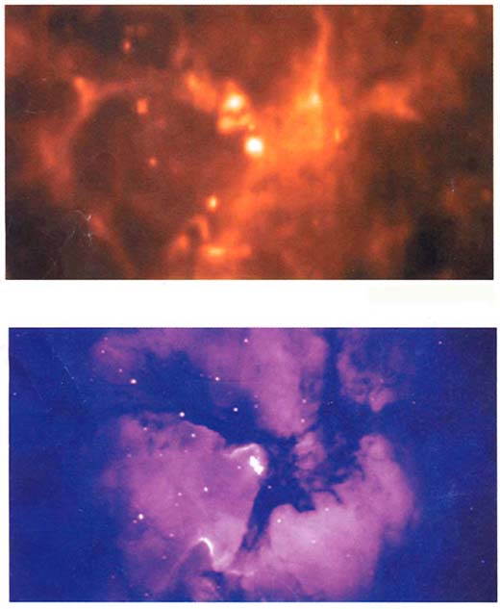

Here are two images of the “Triffid Nebula,” one in the infrared (top) and the other in the visible part of the spectrum (bottom). Notice how the “dark clouds” or lanes so prominent in the visible spectrum (because of extinction by dust) show up as bright regions in the IR image (because the grains emit mostly in the IR). Make sure you understand this! The bright region in the visible image (bottom) is due to emission line and other radiation from gas that is being irradiated by the hot, massive, young stars in this region (you should understand why a massive star must be hot and young). The stars themselves are buried within the dust and show up mostly as the bright spots in the IR image, where they are heating up the dust around them the most.

GAS

Most of the ISM is gas that can be observed in various ways. The densities are very small by Earth standards, only about 1 particle per cubic centimeter on average, but the masses involved in the clouds of gas and dust are very large (ranging from 10² to 10⁶ solar masses) because they are huge (up to 100s of parsecs in size). But there are also “holes” or “voids” where the gas density is much lower than average. The main thing to remember is that the gas is distributed in a very irregular way, probably due to the action of stellar explosions and turbulence, which keeps the gas (and dust) “stirred up.”

21 centimeter HI radiation. This involves the spin flip transition of an electron in a neutral hydrogen atom. An atom with the electron-proton spins parallel has slightly higher energy than e-p spins antiparallel. Transition to lower energy (after excitation by collisions in the cool regions of the ISM) gives a spectral line at 21 cm. (See fig. 18.17.)

This is one of the two major methods for mapping the distribution of gas in our galaxy (and others), because, being in the radio part of the spectrum, this emission line easily penetrates interstellar dust. It was the first method used to make a map of the gas structure of our own Milky Way galaxy, revealing it to have complex structure, from spiral-like “arms,” to large “holes” or “bubbles” and “chimneys” or “fountains” where gas is being vented vertically out of the disk of our Galaxy by stellar winds and explosions (more later).

Also, because this is a spectral line (unlike dust, which gives us only continuous absorption), we can get radial velocities of the gas motions this way (Fig. 18.18). The results show that our galaxy has an overall rotation (we’ll return to this later—this rotation is one of the primary indicators of the existence of “dark matter”), that the gas in our galaxy is highly turbulent (moving supersonically in more-or-less random directions), and often found in “supershells” of expanding gas driven by luminous young stars.
The illustration on p. 479 shows how our solar system is actually located within a cavity bounded by one of these supershells—it is believed that a number of supernovae must have exploded within 40-60 pc of the sun about 10 million years ago to create our current environment. You should read this Discovery 18-1 to see how UV astronomy has been used to map out the “Local Bubble.”

Interstellar Molecules – Interstellar clouds are very cold, with temperatures around 10-100 degrees K. This is just the right temperature to excite the rotational transitions of many molecules; when the excited states decay, they emit a photon in the radio part of the spectrum (Fig. 18.19). This gives us one of our main techniques for mapping cold dense clouds (what would be the other?).

But can molecules survive in the ISM? Only if they are in the densest regions, or “clouds,” where extinction by dust grains protects the molecules from the pervasive UV radiation from massive (so hot) stars in our Galaxy, which would otherwise destroy them. So we expect to see molecules only in the densest clouds. In less dense clouds, there are no molecules and you just see 21cm HI emission.

Over a hundred molecules have been detected and mapped this way, from simple molecules like carbon monoxide (CO), water (H₂O), ammonia (NH₃),… to very complex organic molecules, some which might be “biological precursor” molecules.

Homework: What important molecule was recently discovered in interstellar space and is important because of its relation to biological molecules? The internet will tell you, but you have to know enough to know what to search for! (Actually I will tell you: “interstellar molecules”.) I won’t ask you to memorize its name, but you should find out why this kind of molecule is of a class (aldehydes) that is important for life on Earth, and what the researchers are saying this implies for life in the Galaxy (even though the argument may be weak). You will probably have to look through more than one hit on google.

Unfortunately molecular hydrogen, which comprises most of the gas, doesn’t have any rotational transitions, so we can’t see it. (We can see it by its electronic transitions, but these are in the UV and are only excited in hot ISM regions, like shock waves.)
So we have to use the other molecules as “tracers” of where most of the gas is. By far the most important tracer has turned out to be carbon monoxide (CO). Mapping the sky in the spectral lines of CO has shown that the dense gas is accumulated into clouds of all sizes, from “cores” of sizes ~ 0.1 pc up to giant molecular cloud complexes which can be 50-100 pc across.

Here is an image of the whole constellation of Orion mapped in the CO rotational line: these are the large-scale molecular clouds from which clusters of stars (like the ones shown earlier, visible in the IR) form. Notice the “Horsehead Nebula,” a famous dark cloud in the visible part of the spectrum, and the “Orion Nebula” itself (dotted circle), the nearest hotbed of star formation (about 400 pc away).

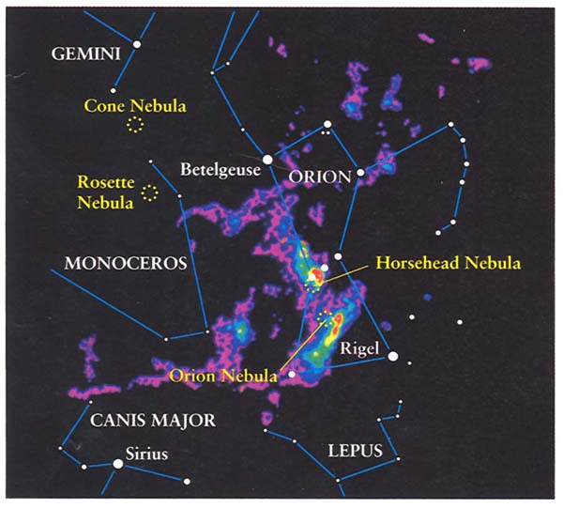

The CO emission is so strong that it can be used as a tracer of fairly dense gas all across our galaxy (again, because the line is in the radio, so dust can’t obscure it), and even in many other galaxies.

However in some regions the gas is so dense that other molecules have stronger emission lines—Figs. 18.21 shows formaldehyde lines in the “Lagoon Nebula” M20.

A major result: Nearly all very young stars (think back: how would you know a star is young, say younger than 10 million years?) are embedded in molecular cloud complexes: these are the birthplaces of stars.
[Note: molecular clouds are just the same objects that we “saw” as dark clouds due to dust extinction. We are just looking at them in two different ways. So it was actually been known that stars form in dense clouds long before interstellar molecules were discovered.]

A huge number of molecules have been discovered in the interstellar medium, most of them in these dense molecular clouds. Some of the simpler of these can be used to trace the denser regions of molecular clouds (for example ammonia NH₃ and carbon monosulfide CS).
Some of them are fairly complex compared to what you’d expect to be able to survive in interstellar space, and even some complex organic molecules that illustrate the ease with which prebiological chemistry can take place. The following table is just so you can see the number of molecules if you are interested.
Following that is an illustration of the emission spectrum of molecules observed in a dense star-forming molecular cloud, so you can see how these molecules are detected, identified, and then analyzed to learn about the chemistry going on in the clouds (part of a whole field called “astrochemistry”). [Sorry for the poor resolution.]

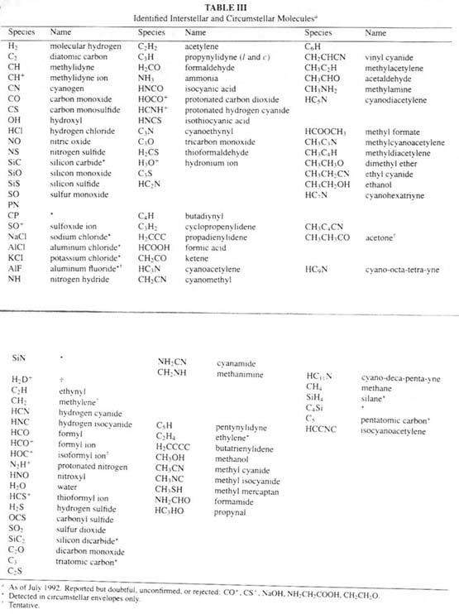
Radio spectrum showing molecular lines in the ISM
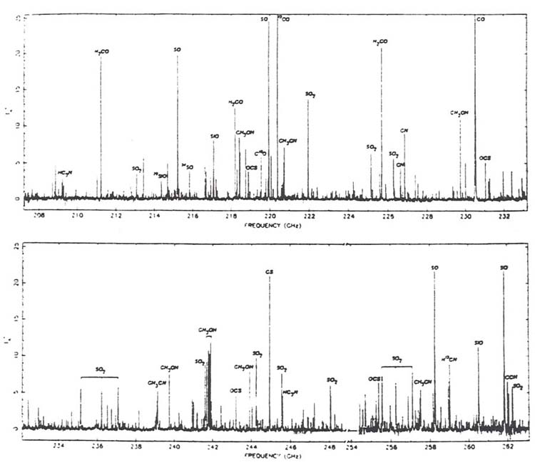

Emission nebulae. (Sec. 18.2) This is just what happens to part of a cloud when a luminous young star is born within it. The star has so much UV radiation that it breaks apart molecules and even H atoms, and heats the gas to about 10,000 degrees. At these temperatures, atoms are moving fast enough to excite various atomic energy levels by collisions, which emit various spectral lines when they decay, as well as continuous radiation. (Go back to ch. 3 if you don’t remember why these conditions are when you get an emission line spectrum.) These are “emission nebulae,” which appear very colorful in the visible part of the spectrum—see the great photographs and zoom-ins for the “Triffid nebula” and the “Eagle nebula” and “Orion nebula” in your book.
[Don’t worry about “forbidden lines” in the text.]
Here is an image, in the visible part of the spectrum, of the “Omega nebula” (taken from your book)—make sure you can explain what is going on in the dark streaks, the bright regions of different colors; what can’t be seen in this visible image?
