Measuring the Properties of Stars (ch. 17)

Stars (and everything) are undoubtedly much more complex than our descriptions of them. Nevertheless, we will try to reduce the nature of stars to a fairly small number of properties that can be used in an attempt to answer questions like:

 Why do there appear to be different “types” of stars?
 How are stars born, evolve, and die?

⇒ First we discuss how the properties of stars are measured and how they can be interpreted (ch. 17).
⇒ Then we do the same for the gas between the stars (the “interstellar medium,” ch. 18) and try to put them together to understand how stars form (ch. 19), especially as a function of mass.
⇒ Finally, in the next section of the course we will consider in detail how stars of different mass evolve from birth to death.

[Not on the exam: Discover 17-1, p. 441, More Precisely 17-1, p. 445; you should just have a basic idea of what the “magnitude system” means when referring to stellar brightnesses.]

Basic properties of stars

1. Distances. The most basic method is to measure a star’s parallax angle, a subject we already covered early in the course. (See Fig. 17.1 for review.) Recall that this method gives rise to the unit of distance we will use throughout the remainder of the course, the parsec, which is the distance of a star with a parallax of one second of arc. (The nearest stars are a few parsecs distant from us, while our Galaxy is about 30,000 parsecs across.) A parsec is about 3 x 10¹⁸ cm, or over a hundred thousand times larger than the distance from the Earth to the Sun (1AU).

Distance (in parsecs) is equal to the inverse of the parallax angle (expressed in seconds of arcs).
For example, a star 10 pc distant has a parallax angle of 0.1 seconds of arc. Distant stars have such small parallax angles that they cannot be measured (recall our discussion of the diffraction and seeing limits for telescopes). So there is a distance limit for this method, and it is only about 100-500 pc. (think: size of our Galaxy ~ 30,000 pc, nearest other galaxies millions of pc away)

The Hipparcos space mission revolutionized our knowledge of parallaxes. Read “Discovery 17-2” on p. 454 on this topic. Planned future space missions (around 2010; SIM and GAIA) aim to enormously extend the distances to which parallaxes can be measured, covering our entire Galaxy.

Important to note: Most objects we’ll encounter in astronomy are too far away to get distances by parallax, so we have to use other, less direct measurements (the idea of “standard candles” is the most important). But parallax is crucial because it serves as the calibration of all these other methods; it is the “yardstick” upon which other distance measurements are based.

2. Motions
We already know how to measure the component of star’s motion along our line of sight, called the radial velocity: obtain a spectrum and measure the Doppler shift using spectral lines.

But the star also has a component across our line of sight; this is called the transverse velocity. All we can directly measure is the angular speed across our line of sight (“proper motion”); in order to get the transverse velocity, we also need the distance. (Think about mosquito/UFO used in class.)
⇒ What kind of star do you expect to exhibit the largest proper motion?

When you combine the two components of velocity, you get the total space velocity of the star. We won’t use this information much until we get to topics like the origin of our galaxy and the evidence for “dark matter.” But you should still know that most stars in the disk of our Galaxy are moving relative to each other at around 5 to 50 km/sec. Our sun and solar system are moving about 15 km/sec relative to the average of nearby stars. But we orbit our Galaxy about 250 km/s.

3. Luminosities. This is how much energy a star is emitting per unit time, i.e. the rate at which photon energy is being emitted. It is exactly the same as the power of a light bulb in Watts. You can think of it as the absolute brightness of the star, to distinguish it from how much energy an observer is receiving from the star, its apparent brightness, which obviously depends on the star’s distance. The three quantities are related by the inverse square law of light:

apparent brightness ∝ luminosity/(distance)²

Since apparent brightness is EASY to measure (if you can see something, you can measure how bright it appears), and we can get distance, at least for some stars, from parallax, we can solve this for L. Examples given in class should make this clear if it’s not already.
[You do NOT have to know anything about “magnitude scales” except the basic idea, if that. I won’t use this idea on the exam, but if you encounter it in the book, just remember that it’s just a handy way to assign numbers to apparent brightness and luminosity that have a smaller range, like the Richter scale for earthquakes.]

4. Temperature. We are talking about the photospheric temperature, which is all we can directly observe. There are 2 ways to get T:

a. Color—remember Wien’s law? Even though stars aren’t perfect blackbodies, we can get fairly accurate temperatures (especially in a relative sense) by colors. See p. 446-7, esp. Fig. 17.9, so that you understand “color” as a measure of how much energy is being radiated in two different wavelength bands.

b. Spectra and spectral classification—We’ve already discussed how the strengths of spectral lines of different elements are extremely sensitive to the temperature of the gas. E.g. if helium lines, star’s photosphere must be really hot, since it takes so much energy to excite its electron levels. Look carefully at Fig. 17.10 to see how different absorption lines appear for stars of different temperatures.
Astronomers have classified stars into spectral types that turn out to be a temperature sequence in the order”
O B A F G K M ⇒ memorize this
50,000K ………………..6,000K…….3,000K ← temperature
HeII HeI H various metals molecules ← strongest lines

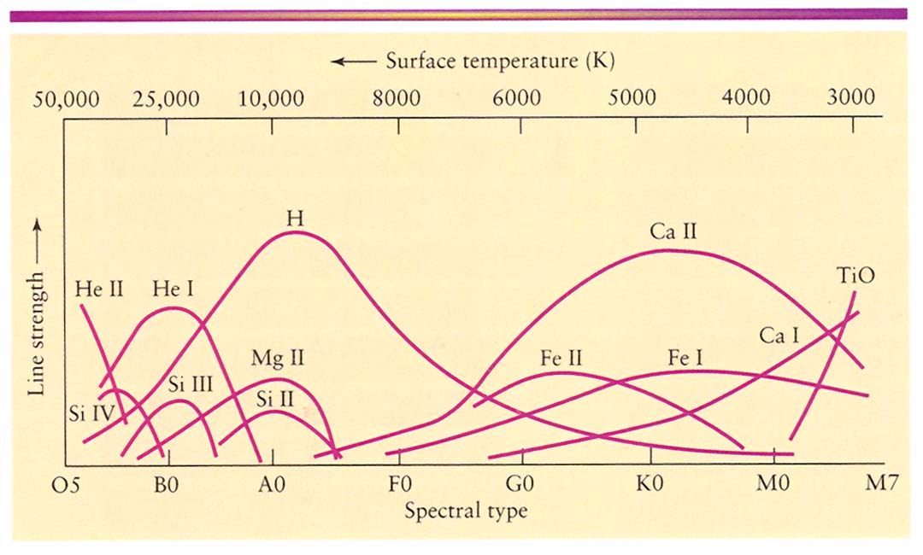

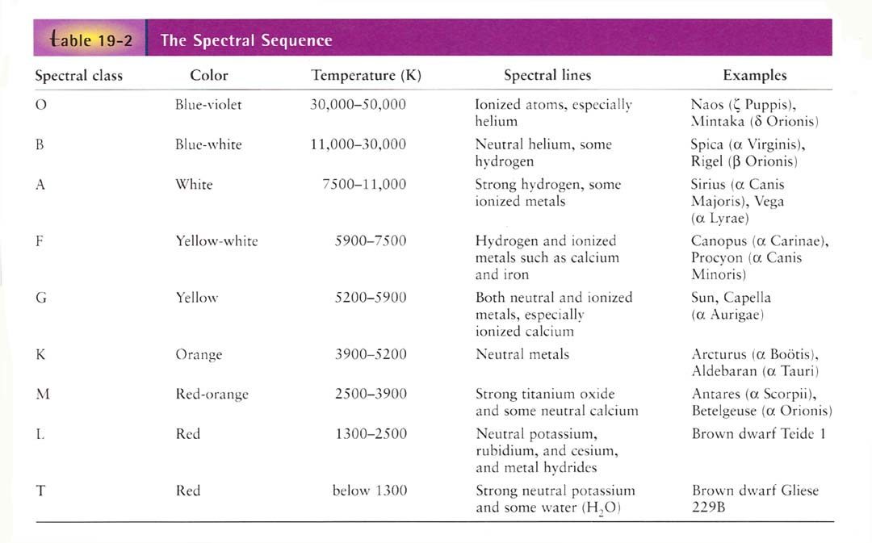

5. Sizes.
Since stars only appear as points of light to even the largest telescopes (with a very few exceptions, using interferometry for the largest nearby stars: see Fig. 17.11 for the best example), we can’t get their diameters directly. Instead we use a method that is based on Stefan’s law (see ch.3 if you have forgotten): The rate of emission of energy of all light, at all wavelengths, by an object, by a unit area of its surface, per unit time (e.g. per second), E, is proportional to the fourth power of the surface (photospheric) temperature T⁴. Writing L for the luminosity (total energy emitted per unit time by the whole object) of the object (we’ll see how to measure this shortly), and noting that the area of a star is proportional to the square of its radius, this gives
E ∝ L / R² ∝ T⁴ ; or L ∝ T⁴ R².
You can see there are two ways for a star to be luminous: have a high temperature and/or have a large surface area. This means that if we can measure the temperature (from color, or using spectral lines; see below), we can get the surface area, i.e. the size R:

R ∝ L^{1/2} / T² .

Don’t worry much about the exponents, just understand the idea.

If you carry this out for a large number of stars (see Fig. 17.12), you find that most of them have R similar to the sun (these are called “main sequence stars”), but a fraction of them are either:
(a) red giants – large L (up to 10⁶ x sun) and small T (i.e. red), so must have large size (up to 1000 x sun’s);
(b) white dwarfs – T fairly large (“white”), but faint, L only a few percent of sun. This means they must not have much surface area, i.e. their sizes are tiny (comparable the size of the Earth!), even though their masses are similar to the sun’s. They must have huge densities! (Later we’ll see what these classes represent in terms of evolution.)

NEXT: The HR diagram (extremely important)—read sec. 17.5.

The H-R diagram (sec. 17.5)

The H-R diagram is a graph of luminosity vs. temperature for individual stars. This will be our basic device for describing the evolution of stars so it is important to be comfortable with it. [Notice that temperature increases from right to left. Also note that stars evolve on timescales of at least millions of years, so we don’t see them move around in this diagram. We watch models of stars move around. More in later chapters.]

Understand from earlier notes why stars in the upper right of this diagram must have large sizes (red giants) while those in the lower left (white dwarfs) must be small (white dwarfs).

Also read why plotting only the stars that are apparently the brightest would be very misleading. We need to plot all the stars out to some distance. The textbook has some useful graphs (pp. 452, 453) illustrating this point. The next plot shows an HR diagram showing all the stars with Hipparcos distances. This is still highly biased toward the brightest (as well as most numerous) stars. Also note that the width of the main sequence is pretty large—this is because the main sequence varies somewhat for stars with different “metal” abundances.
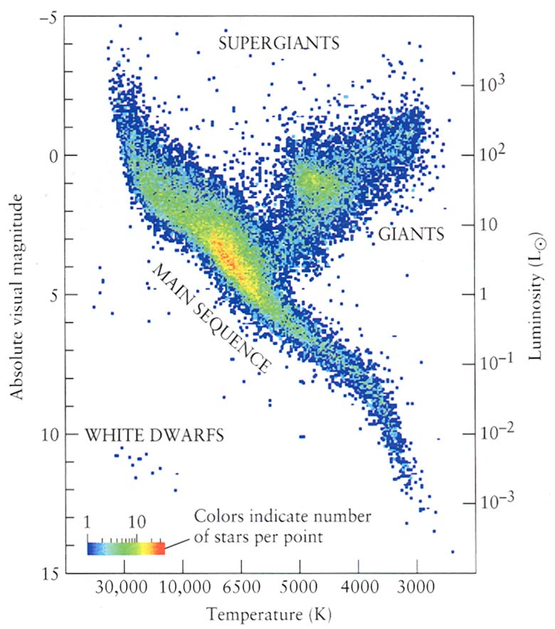

HR diagram for stars with Hipparcos distances.

If we use a complete sample of stars (i.e. not biased by how bright they appear) we find:
~90% main sequence (MS) stars
~1% red giants
~9% white dwarfs
Why? That’s the purpose of stellar evolution theory, but you can already guess a couple of possible answers.
You should be comfortable answering the “Concept Check” on p. 455 if you understand this.

Spectroscopic Parallax

If you can establish that a star is a main sequence (MS) star (and you can—from its spectrum; see “luminosity class” in text), then the spectral type gives you the temperature, so you can just read off the luminosity from the H-R diagram.

Knowing the apparent brightness (really easy to measure) and luminosity, this gives the distance (review earlier material if you don’t understand this), without having to get a trigonometric parallax. Distances obtained in this way are called “spectroscopic parallaxes.” (In “spectroscopic parallax” the word parallax is just used to mean “distance.”)

You can get distances out to roughly 10,000 pc (10 kiloparsecs) using this method. (Compared to about 500 pc for trigonometric parallax.)

This is our first example of using a “standard candle”: some property of the star (in this case its temperature) gives you its luminosity (hence the analogy with a candle or light bulb).

Stellar Masses
The only method for directly determining the masses of stars is from binary stars, using Newton’s form of Kepler’s 3rd law. There are three types of binary stars, which depend on how close they are to each other, their relative brightnesses, the distance of the binary, and other factors:

a.Visual binaries—can see both stars, and so monitor orbit directly. (But must be near enough for you to resolve the two stars—not that many of these!) See Fig. 17.19. Notice that you need the distance to convert the angular separation of the binary pair into a linear separation (i.e. in km or AU).

b.Spectroscopic binaries—in this case you might see one or both stars, but the way you can tell they are in orbit is by observing periodic changes in the Doppler shift of their spectral lines. See Fig. 17.20. The period of the radial velocity variation is the period of the system. Using this, you can estimate the semimajor axis (for a circular orbit, the period = 2π x orbital radius/orbital velocity). So with period and semimajor axis, can get masses (actually only lower limit—inclination; see text).
Recall that this is how extrasolar planets were discovered (the “radial velocity method”).

c. Eclipsing binaries – only get eclipses if the orbit is very nearly along the observer’s line of sight, i.e. edge-on (so favors very small orbits), but can get lots of information, even the sizes of the stars, from the light curve. (See Fig. 17.21)
Recall that this is the basis for the “transit method” that we discussed in relation to extrasolar planet detection.

Generally, get only limits on stars’ masses, but in many cases (e.g. spectroscopic eclipsing binaries) can get actual masses. See pp. 459-460.

Results: accurate masses for ~ 100 stars, showing that they span the mass range ~ 0.1 to 50-100 solar masses. Why this range? That is subject of future chapter, but for now, the most important thing we learn from this is an estimate of the lifetimes of stars, and how they depend on mass. This comes from:

The mass-luminosity relation for main sequence stars (sec. 17.8). Roughly, find from observations that L ∝ M³. This tells us that the mass varies continuously along the main sequence. Range is roughly 50 solar masses (luminous hot stars, spectral type O) to about 0.1 solar masses (faint cool stars, spectral type M). But notice strong mass-dependence of luminosity!

Theory tells us that the mass a star is born with determines nearly everything else about its fate.
Good example:
stellar lifetime = fuel supply/rate at which it is being burned
∝ stellar mass / stellar luminosity
∝ M / M³ ∝ 1/M²
So low mass stars live the longest. Numerically, find a lifetime of about a few million years for 50 solar masses, 10 billion years for the sun, and about a trillion years (much greater than the estimated age of our universe) for the lowest mass stars.
Now stare at Table 17.5 (Measuring the Stars) and see if it all makes sense to you. Try the questions at the end of the chapter before moving on!

Next (ch.18): try to understand the properties of material (the interstellar medium) from which stars form.

