Lecture Outline: Chapter 5: Telescopes

You don’t have to know the different types of optical reflecting and refracting telescopes.
Important to understand the difference between “imaging,” “photometry,” and “spectroscopy” (sec. 5.2).

There are really only two topics here: light gathering power and resolution—the latter involves the most considerations by far.

Light gathering power—determines how faint an object you can detect. This will be proportional to the area of the collector, so ∝ D² where D is the diameter of the telescope. Read text on largest telescopes, future designs, etc.

Angular resolution
You must get used to angular measure here. Try
to keep in mind some examples, e.g. 1 arc sec is equivalent to the angle subtended by the breadth of a hair view from about 30 ft, or a penny viewed from 3.6 km.
The resolution of the human eye is about 60 arcsec. For best telescopes, e.g. adaptive optics or HST ≈ 0.05 arc sec, radio interferometer ≈ 0.001 arc sec. [See below]

There are two limits that set how good your resolution is:
1. diffraction limit ∝ λ / D (just due to the fact that you’re using an instrument with edges and boundaries—see text)

So resolution poorer at radio than, say, optical for a given D; i.e. D has to be huge for radio telescopes

One way around this, which has almost entirely been used for radio telescopes so far, is to use interferometers—several radio telescopes used to simulate one huge telescope in order to get great resolution. Biggest interferometers can get amazing resolutions of 0.001 arc sec or better! (Read sec. 5.6)

Here are some pictures of present-day large-baseline interferometers:

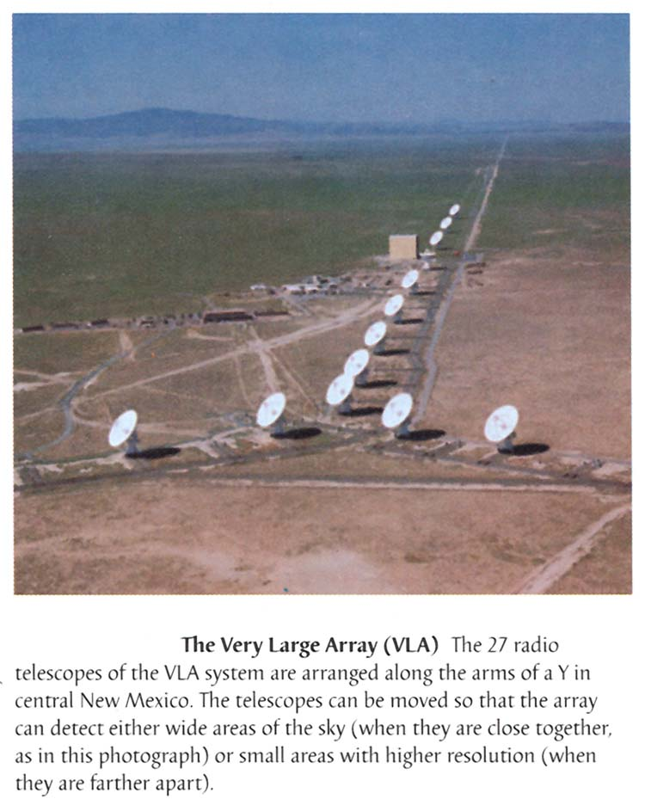

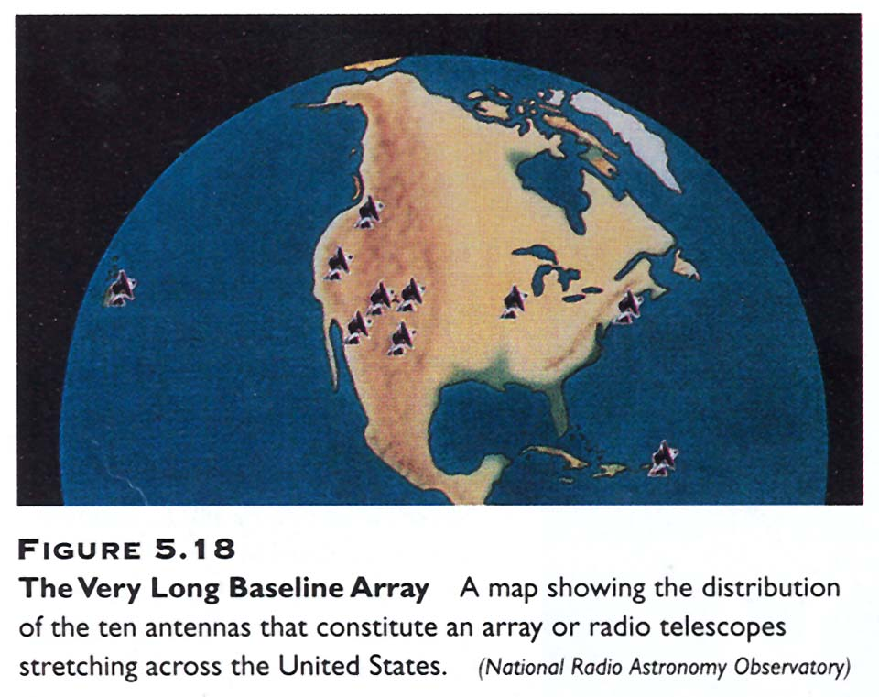

- seeing limit (due to Earth’s atmospheric scintillation, i.e. “twinkling”)
Here is a visual example of how scintillation makes stellar images “fuzzy”:

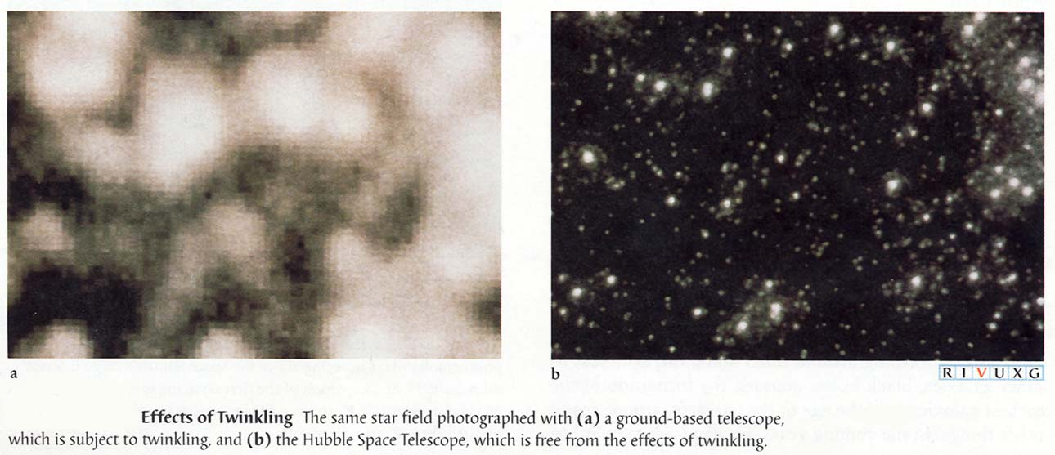

For a ground-based optical telescope the best res. ≈ 1 arc sec.

One way around this is to use adaptive optics in which the mirror constantly and rapidly adjusts its orientation and shape (sometimes thousands of times per second!) in order to compensate for scintillation. (See discussion sec. 5.4)
Another way is to just get above the earth’s atmosphere: space telescopes (Hipparcos, IRAS, Hubble Space Telescope HST, SIRTF, Chandra,…Sec. 5.7)
Both of these can get resolutions approaching 0.05 arc sec or less.

Additional considerations:
1. Atmospheric transmission--Besides being responsible for seeing, the Earth’s atmosphere also just blocks out light. Visible and radio wavelengths are least affected (recall material from ch.3). For other wavelength regions, need satellite observatories or at least very high mountains (same for visible because of seeing). (Sec. 5.7)

2. CCDs—Photographic plates only capture about 1% of the light, while charge-coupled devices (CCDs) can get about 75% efficiency, and extremely accurate. (sec. 5.2 in text)

3. Infrared telescopes—special problem: must be cold, because the telescope itself emits IR radiation. Also, best when above the Earth’s atmosphere to avoid molecular absorption (see 1 above). (Sec. 5.7)

4. X-ray and gamma-ray observations—All must be done far up in Earth’s atmosphere because absorption is so strong. Need special telescopes, since these don’t reflect off mirrors the way that longer-wavelength light does (why not?). Briefly discussed in class.
See book sec. 5.7 for more details.

